

**Course:**

Machine Learning

**Type:**

Report

**Instructor:**

Dr. Alaa Al-Habashneh

**Student:**

Nadeen Ali

**ID:**

22110361

**Submission:**

Fall Semester 2024/2025

Table of Contents

**PARTS 1 & 2 – THEORITICAL FOUNDATION** 3

**1.1 Classification Vs. Regression Problems** 3

**1.2 AI System for Autonomous Cars** 4

**1.3 SVM** 6

**1.4 Sigmoid Function** 7

**1.5 Decision Tree & Entropy** 8

**1.6 Logistic Regression** 9

**1.7 Gradient Boosting** 10

**1.8 ROC vs. Confusion Matrix** 11

**1.9 Overfitting vs. Underfitting** 13

**1.10 Simple Linear Regression** 15

**1.11 Regression Evaluation Model** 15

**1.12 Polynomial Regression** 18

**PART 3 – PROBLEM STATEMENT** 19

**3.1 Problem Statement & Requirements** 19

**3.2 ML Algorithms: Suitable** 20

**3.3 ML Algorithms: Comparison** 21

**PART 4 – MODEL DEVELOPMENT** 23

**4.1 Dataset: Details** 23

**4.2 Data Splitting** 24

**4.3 Model Training** 35

**4.4 Model Training: Details** 39

**PART 5 – MODEL EVALUATION** 40

**5.1 Performance Metrics** 40

**5.2 Three Way Split: Best Model & Prediction** 41

**5.3 Results: Reliability** 46

**5.4 Results: Analyzation** 56

**5.5 Models: Strengths vs. Weaknesses** 59

**5.6 Future Improvements** 61

**CONCLUSION** 62

**REFERENCES** 62

# **PARTS 1 & 2 – THEORITICAL FOUNDATION**

# **1.1 Classification Vs. Regression Problems**

***Question 1:*** In this section, we will be exploring some questions to explore whether the stated problem is a classification or regression problem, whether we are inferring or predicting, *and* the number of observations and features for said problem.

1. **Problem #1:** We collect a set of data on the top 500 firms in the US. For each firm we record profit, number of employees, industry and the CEO salary. We are interested in understanding which factors affect CEO salary.

* **Regression:** We are predicting salary, which is a continuous value and does *not* fall under a certain class or category
* **Inference:** We want to know what affects the CEO’s salary, meaning we are exploring the impact and influence of the other features with the salary.
* **n (observations) = 500:** We are collecting data on the top *500* firms in the US
* **p (features) = 3:** Profit, number of employees, and industry of the firm. The CEO’s salary is *not* a feature, it’s our target.

1. **Problem #2:** We are considering launching a new product and wish to know whether it will be a success or a failure. We collect data on 20 similar products that were previously launched. For each product we have recorded whether it was a success or failure, price charged for the product, marketing budget, competition price, and ten other variables.

* **Classification:** We are predicting whether the launch of a new product is a success (1) or a failure (0), thus belonging to some specific class or category and the result *cannot* be of any other value besides those two.
* **Prediction:** We simply want to predict the success of a product based on historical data using specific features and pattern recognition.
* **n (observations) = 20**: We are collecting 20 similar products to test their success
* **p (features) = 13:** Price charged, marketing budget, competition price, and 10 other unnamed variables total to 13 features. Success of the product is our target

1. **Problem #3:** We are interested in predicting the % of change in the USD/Euro exchange rate in relation to the weekly changes in the world stock markets. Hence, we collect weekly data for all of 2012. For each week we record the % of change in the USD/Euro, the % change in the US market, the % change in the British market, and the % change in the German market.

* **Regression:** We are predicting a percentage of change, which cannot be classed under a specific category and thus is a continuous value.
* **Prediction:** We’re forecasting a future percentage of change in the USD/Euro exchange rate based on historical data without considering why
* **n (observations) = 52:** We are collecting data on a weekly basis for the entire year of 2012, totaling to 52 weeks.
* **p (features) = 3:** The features include % change in the US market, % change in the British market, & the % change in the German market. The % of change in the USD/Euro is the target, thus not counted as a feature.

# **1.2 AI System for Autonomous Cars**

***Question 2:*** In this section, we’ll be exploring the development of an AI system as part of a university team for an autonomous car. We must analyze whether these tasks are supervised or unsupervised learning problems, suitable algorithms for them and their time complexities, *and* why the use of a machine learning model is essential.

1. **Lane Detection:** The car must identify lanes on the road using video feed from its cameras.

* **Supervised:** The model will be trained on labeled datasets containing lane and street image and footage (pavement, lane lines, cars, etc.), thus the model will be able to identify lanes from prior *knowledge* on what a lane is.
* **Algorithm – Random Forest:** By combining several decision trees, this ensemble method creates a strong model that ranks the crucial characteristics for identifying whether a particular lane is "lane" or "not lane," enhancing predictions. SVM may be helpful in this situation, but its scalability is constrained by the anticipated size of the dataset. However, our ensemble technique easily handles big datasets while maintaining excellent accuracy.
* **Time Complexity:** Where T = number of trees, n = number of data, and log n = maximum tree depth, the training takes O(T*n*log n) time, while prediction takes O(T*log n) time.
* **ML Essentiality:** Real-time visual data analysis from cameras is necessary for lane identification as it takes into account different road conditions (unseen road designs, unclear lane markers, shadows, so on). These situations are outside the scope of traditional rule-based systems, however, machine learning algorithms like Random Forest can aid the car in successfully classifying lanes, reducing the need for human intervention and guarantees safe navigation.

1. **Traffic Sign Recognition:** The system needs to classify and recognize traffic signs (e.g., stop signs, speed limits)

* **Supervised:** Both traffic signs and speed limits are classification problems that are easily labeled and learned through datasets showing different traffic signs and speeding limits to teach the model correct classification and appropriate actions based on classified data.
* **Algorithm – SVM:** The recognition of traffic indicators is a straightforward classification problem. SVM is an excellent choice for this problem as it can *easily* create a margin that separates these classes. The usage of non-linear SVM kernels aid the model to handle more complex patterns, guaranteeing accuracy even when signs are not easily seen (due to camera quality lighting, etc.)
* **Time Complexity:** Where n = number of data and d = number of features, the training takes either O(n^2*d) or O(n^3) time *depending* on the hyperparameter (optimization technique) used, while prediction takes O(v*d), where v = number of support vectors.
* **ML Essentiality:** Traffic and speed sign can vary in their appearance (lighting, bad quality, shapes, color, etc.), but machine learning algorithms like SVM may be able to identify these signs and accurately classify them due to pattern recognition and learning within the data, allowing the car adjust to new or undetected signals. Rule-based systems are impractical since they would need a lot of code to handle every possible variation.

1. **Driving Pattern Analysis:** Analyze large datasets of driving patterns from previous trips to group similar driving behaviors for further analysis (e.g., aggressive vs. defensive driving).

* **Unsupervised:** There is no specific benchmark for driving behavior, thus there are *no* labels for said behavior. Rather, driving behaviors will be grouped or clustered based on other features and values according to the model’s pattern recognition.
* **Algorithm – Random Forest:** When driving habits lack labels, Random Forest is an excellent choice as it can analyze complex data and cluster it according to hidden patterns. The combination of multiple decision trees helps the model learnfrom the data in *different* ways, combining all predictions in the end with a more accurate and reliable model and becoming stronger against noises in the data.
* **Time Complexity:** Where T = number of trees, n = number of data, and log n = maximum tree depth, the training takes O(T *n* log n) time, while prediction takes O(T*log n) time.
* **ML Essentiality:** Learning what unlabeled behaviors look like involves working with *large*, complex, and unstructured datasets – so, the usage of traditional methods will be exhausting, lead to missing hidden patterns and the inability to cluster behaviors accurately. However, machine learning models such as the Random Forest can unveil these patterns within the data and to properly classify and understand a drivers’ driving behaviors for safer cruising and driving strategy recommendations.

1. **Collision Prediction:** Predict whether a collision is likely based on real time sensor data (e.g., LIDAR and radar)

* **Supervised:** Real time sensor data can easily be learned and used to predict the existence of a collision (1) or the lack of one (0), which is easily labelled.
* **Algorithm – Logistic Regression:** Determining whether a collision is likely (1) or not (0) is a simple binary classification problem which Logistic Regression excels at.
* **Time Complexity:** Where n = number of data and d = number of features, the training takes O(n * d) times while prediction takes just O(d) time.
* **ML Essentiality:** Predicting whether a collision is likely to happen based on real-time sensor data needs a *deep* study of features and their relationship with potential collisions. Due to the abundance of possible combinations, traditional methods will not be able to cover all cases – thus, the usage of machine learning models such as Logistic Regression will effectively handle these complex relationships and ensure the car is able to anticipate potential collisions to avoid them in a timely manner.

1. **Anomaly Detection:** Detects unusual patterns in sensor data, such as faulty readings from a sensor.

* **Unsupervised:** Similarly to the driving pattern analysis problem, there is no predefined label for abnormal labels in data, thus the model will have to learn what a ‘normal’ sensor looks like based on historical data, then classifying it.
* **Algorithm – XGBoost:** Similar to the 3rd task (*Driving Behavior*), there no clear label for ‘faulty’ readings – thus, the usage of an ensemble method such as XGBoost improves the model in *iterations* through weak learners, guiding the final model to enhance its predictions based on misclassifications, slowing learning and labeling what ‘faulty’ readings are.
* **Time Complexity:** Where T = number of trees, n = number of data, and log n = maximum tree depth, the training takes O(T * n * log n) time, while prediction takes O(T * log n) time.
* **ML Essentiality:** Its crucial to detect anomalies in sensor data to ensure the overall reliability of the car as faulty sensor readings can jeopardize the safety of the driver and passenger. Such a task is *incredibly* complex with many relationships between diverse features, which traditional methods cannot label and solve. However, machine learning models like XGBoost can identify and label what a ‘normal’ sensor looks like to enhance the car’s safety with appropriate responses.

**ML Essentiality – Overall Car**

Using machine learning algorithms across all these tasks for the creation of an autonomous car is essential for *many* reasons as mentioned above. In short, it makes a car more adaptable to new and unseen information, increases its safety with accurate and real time predictions and decisions, *and* is able to handle a larger amount of data to learn from and improve the car’s sense of understanding.

# **1.3 SVM**

***Question 3 -*** Based on the plot below, find the weights w and the bias b based on a decision boundary found using SVM. Explain the steps followed in detail.

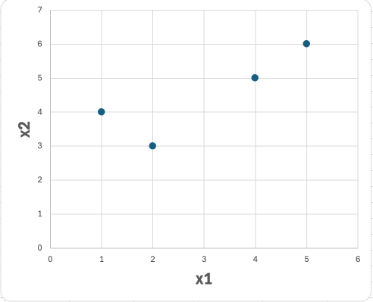

|  |  |  |
| --- | --- | --- |
| **x1** | **x2** | **Label** |
| 1 | 4 | -1 |
| 2 | 3 | -1 |
| 4 | 5 | 1 |
| 5 | 6 | 1 |

***Answer***, **figure (1)** – The following figure explains all the steps taken to answer question 3.

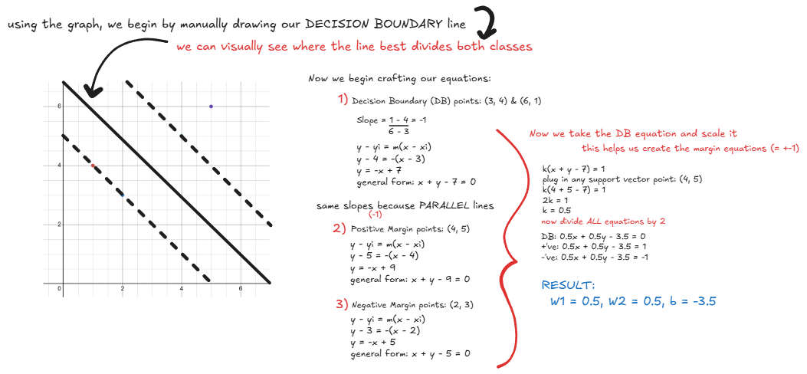

**Figure 1**

# **1.4 Sigmoid Function**

***Question 4 -*** Explain why using the sigmoid function in logistic regression allows the model to solve classification problems instead of regression problems? Give an example. Can you use a sigmoid function for multiclass classification? Explain.

***Answer -*** The Sigmoid function helps the logistic regression model solve classification problem by converting any input as a probability between 0 and 1. How it does so is by classifying the data into binary categories based on some threshold (0.5), the inflection point, where the sigmoid function’s graph immediately transitions from class 0 to class 1. The Sigmond’s function is incredibly simple, so here’s a quick written example, **figure (2):**

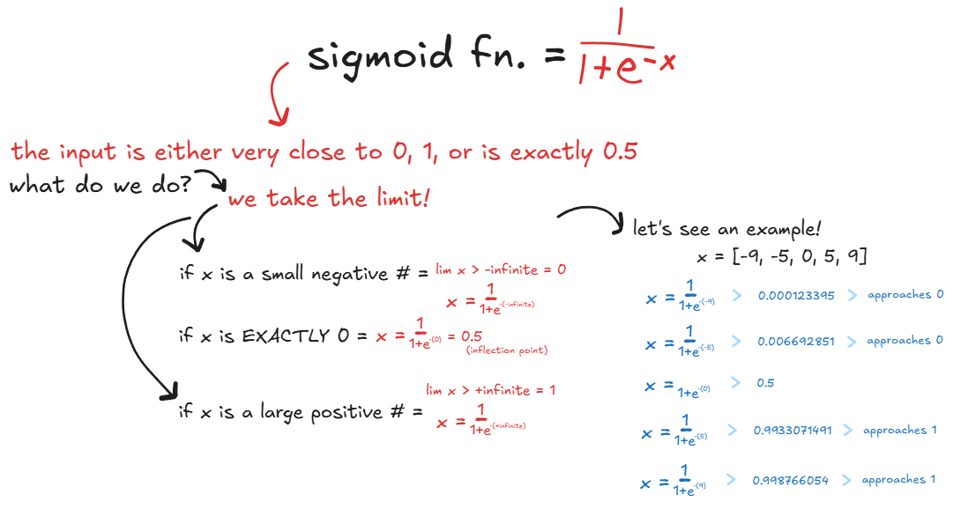

**Figure 2**

# **1.5 Decision Tree & Entropy**

***Question 5 -*** Using the dataset in the table below, find the entropy and information gain (IG) for each feature. Then, continue with the same approach to construct and draw the full decision tree learned from this data (without any pruning).

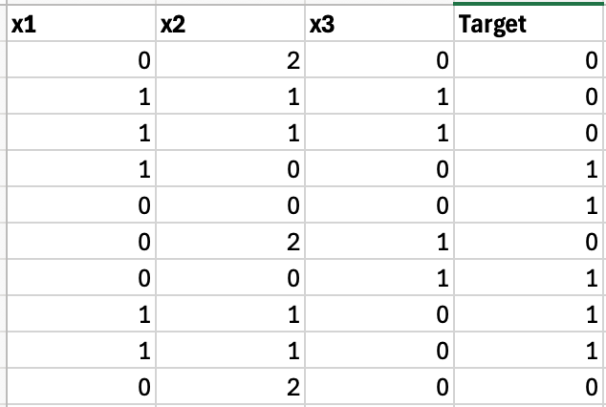

***Answer,* figure (3) –** The following figure explains all the steps taken to answer question 5.

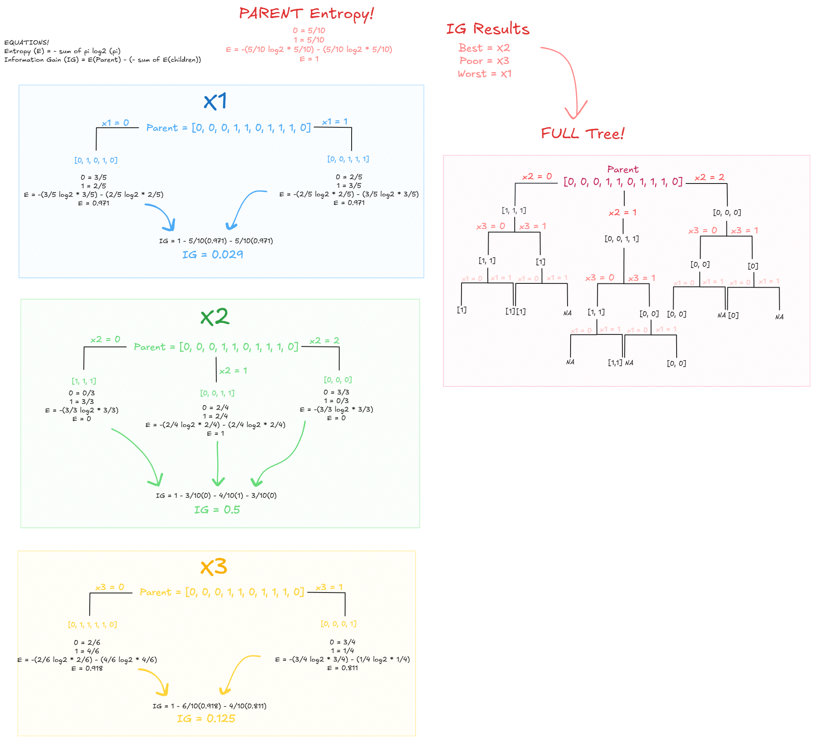

**Figure 3**

# **1.6 Logistic Regression**

**Question 6 -** Suppose we collect data for a group of students in a class with variables X1 = hours studied, X2 = undergraduate GPA, and Y = receive an A. We fit a logistic regression model and produce estimated coefficients B0 = -6, B1 = 0.05, B2 = 1

1. Estimate the probability that a student who studies for 40 hours and has an undergraduate GPA of 3.5 gets an A in the class.
2. How many hours would the student in part (a) need to study to have a 50% chance of getting an A in the class?

***Answer,* figure (4) –** The following figure explains all the steps taken to answer question 6.

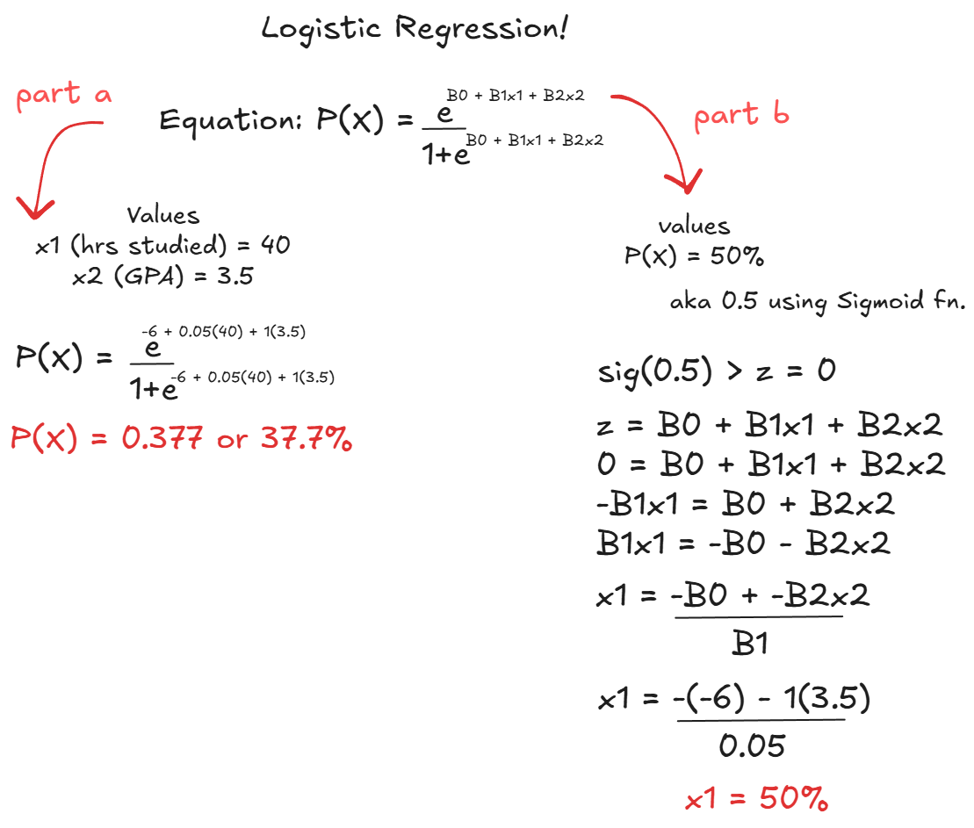

**Figure 4**

# **1.7 Gradient Boosting**

***Question 7 -*** *You* are using gradient boosting with the following setup:

1. Initial Prediction: f0(x)=12 for all instances.
2. Learning Rate: η=0.1

Tasks:

1. Calculate the initial residuals after f0(x)
2. Update predictions after the first weak learner
3. Compute the residuals for the second iteration
4. Update predictions after the second weak learner
5. Explain how the algorithm improves the prediction after each iteration?

***Answer*, figure (5) –** The following figure explains all the steps taken to answer question 7.

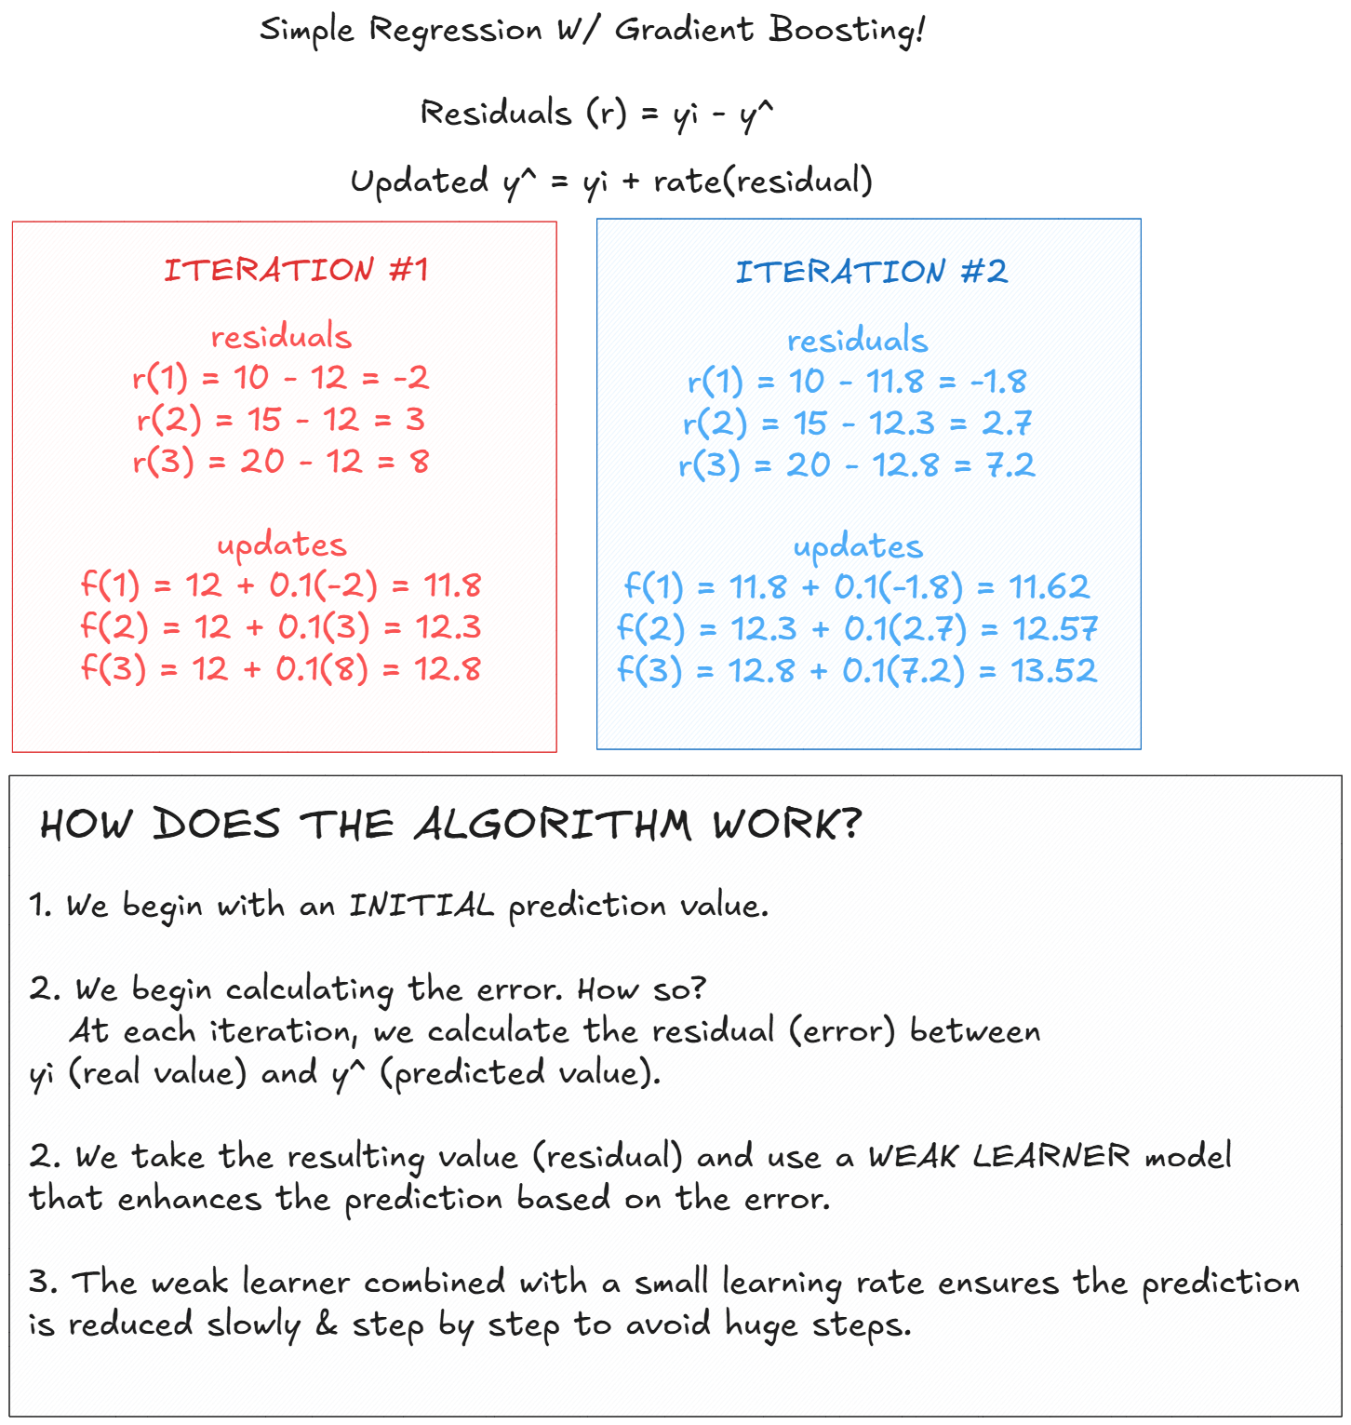

**Figure 5**

# **1.8 ROC vs. Confusion Matrix**

***Question 8 -*** Given the following classifier outputs and thresholds, calculate the True Positive Rate (TPR) and False Positive Rate (FPR) for the threshold of 0.6, and explain how these points contribute to the ROC curve. Explain the purpose of the ROC curve? When is it favored to be used over a confusion matrix?

|  |  |  |
| --- | --- | --- |
| **Instance** | **True Label** | **Predicted Probability** |
| 1 | Positive | 0.8 |
| 2 | Negative | 0.7 |
| 3 | Positive | 0.65 |
| 4 | Negative | 0.4 |
| 5 | Positive | 0.3 |

***Answer*, figure 6 –** The following figure explains all the steps taken to answer question 8

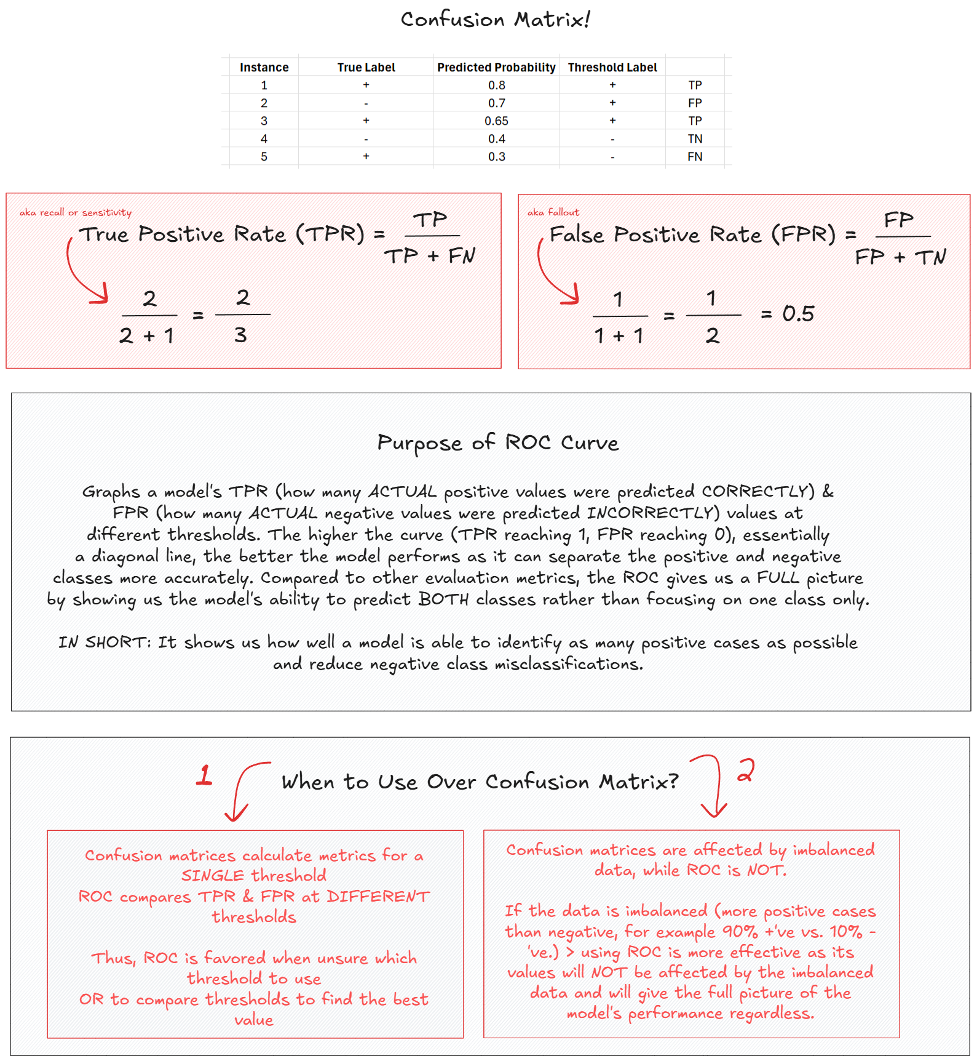

**Figure 6**

# **1.9 Overfitting vs. Underfitting**

***Question 9 -*** What are the key signs of underfitting and overfitting during the model evaluation process? What are the primary causes of overfitting, and how can it be mitigated? Provide at least three techniques

***Answer –***

**Definition:** Overfitting is when a model is too complex and predicts the training data almost too well, if not perfectly, while underfitting is when a model is too simple and thus unable to predict the training data well enough and is usually biased to some value. In other words, overfitting occurs when the model has high variance and low bias compared to underfitting which occurs due to low variance and high bias. Both cases are considered a failure as a machine learning model must be able to recognize patterns within the training data well enough to produce accurate predictions while being able to maintain a generalized structure to continue the accurate predictions even when unseen data is introduced.

**Key Signs During Evaluation:** Models that are considered underfitting will have high errors in both the training and testing sets as the model is too simple and cannot capture patterns nor generalize well. Also, when graphing an underfitted model’s predictions vs. the real data, we can visualize its poor ability at capturing the general trend of the data. As for overfitting, it will have low training errors as it has learned (or rather memorized) the training set too well, but high testing errors due to its inability to generalize to unseen data. As for its graph vs. the real data, its line will follow the real data perfectly.

**Overfitting Causes**

1. **Too Many Features:** An abundance of features can lead the model to learn the training data too well and predict it almost if not perfectly.
2. **High Model Complexity:** A complex model (too many parameters, flexible architecture, etc.) can end up memorizing the training data samples including noise data (outliers) rather than detect patterns.
3. **Small Training Set:** there isn’t enough data samples for the model to recognize underlying patterns and generalize its overall structure, thus fitting the existing, small dataset too well.

**Overfitting Mitigation Techniques**

1. **Early Stopping:** The training phase is paused before the model begins learning the noises, allowing the model to focus on recognizing generalized patterns.
2. **Pruning:** Some features or parameters may be irrelevant and add unnecessary complexity to the model – thus, pruning, also known as feature selection, helps identify the most important features in the training set and prioritizes them, eliminating the irrelevant features.
3. **Regularization:** Penalizes the model for prioritizing/depending on irrelevant features, guiding it to focus on the overall pattern in the data. It assigns smaller weights to said irrelevant features to ensure generalization to new data.
4. **Ensembling:** The combination of different machine learning algorithms’ (weak learners) predictions to result in a final, more accurate model.
5. **Data Augmentation:** Transformations (flipping, rotating, scaling, etc.) are introduced to the training dataset to appear ‘new’ to the model each time it interprets it, improving generalization and preventing the model from ‘memorizing’ the sample data.

# **1.10 Simple Linear Regression**

***Question 10 -*** You are given the following dataset for simple linear regression:

|  |  |
| --- | --- |
| **x** | **y** |
| 1 | 2 |
| 2 | 3 |
| 3 | 5 |
| 4 | 6 |
| 5 | 8 |

Tasks:

1. Calculate the slope (m) and intercept (b) of the best-fit line using the least squares method (closed form expression).
2. Write the equation of the best-fit line y^ ̂= mx + b

***Answer*, figure (7) –** The following figure explains all the steps taken to answer question 8

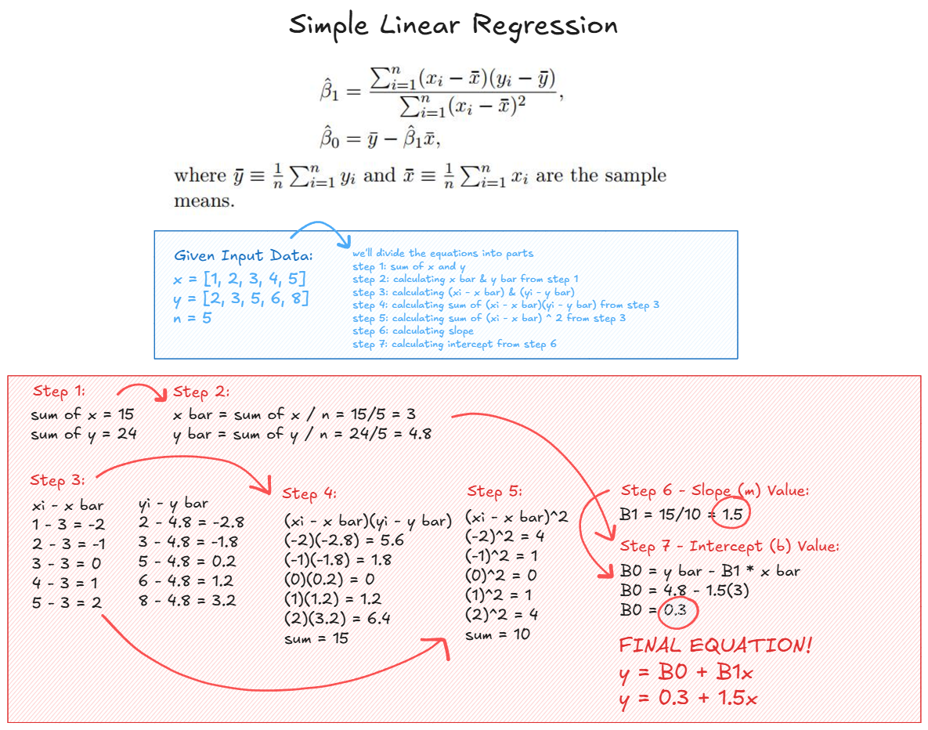

**Figure 7**

# **1.11 Regression Evaluation Model**

***Question 11* -** You are given the following data for a regression model:

Tasks:

1. Calculate the mean of the observed values

|  |  |
| --- | --- |
| **Observed (y)** | **Predicted ($\hat{y}$)** |
| 3 | 2.8 |
| 4 | 4.2 |
| 5 | 5.0 |
| 6 | 6.1 |
| 7 | 6.9 |

1. Compute the total sum of squares (SST)

***Answer*, figure (8) –** The following figure explains all the steps taken to answer question 11

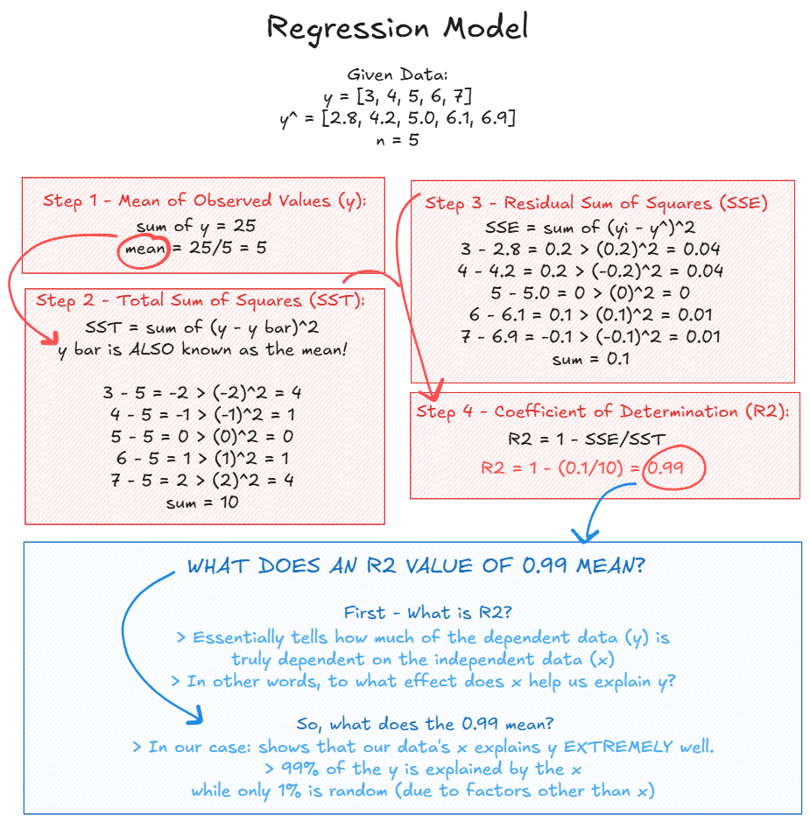

**Figure 8**

# **1.12 Polynomial Regression**

|  |  |
| --- | --- |
| **X** | **Y** |
| 1 | 2 |
| 2 | 5 |
| 3 | 10 |
| 4 | 17 |
| 5 | 26 |

***Question 12* -** You are given the following dataset with a single independent variable X and a dependent variable Y:

You are tasked with fitting two different polynomial regression models and determining which one provides the best fit to the data. The models are as follows:

1. **Model 1 (2nd-degree polynomial)**

* ***Equation*:** Y ̂=β0 + β1.X + β2.X2
* The coefficients for Model 1 are given as: β0=1, β1=1, β2=1

1. **Model 2 (3rd-degree polynomial):**

* ***Equation*:** Y ̂=β0 + β1.X + β2.X2 + β3.X3
* The coefficients for Model 2 are given as: β0=0, β1=1, β2=1, β3=−0.2

**Tasks:**

1. Calculate the predicted values Y ̂ for both models using the given coefficients.
2. Calculate the R2 (coefficient of determination) for both models.
3. Compare the R2 values of both models.
4. Interpret the results.

***Answer*, figure (9) –** The following figure explains all the steps taken to answer question 12

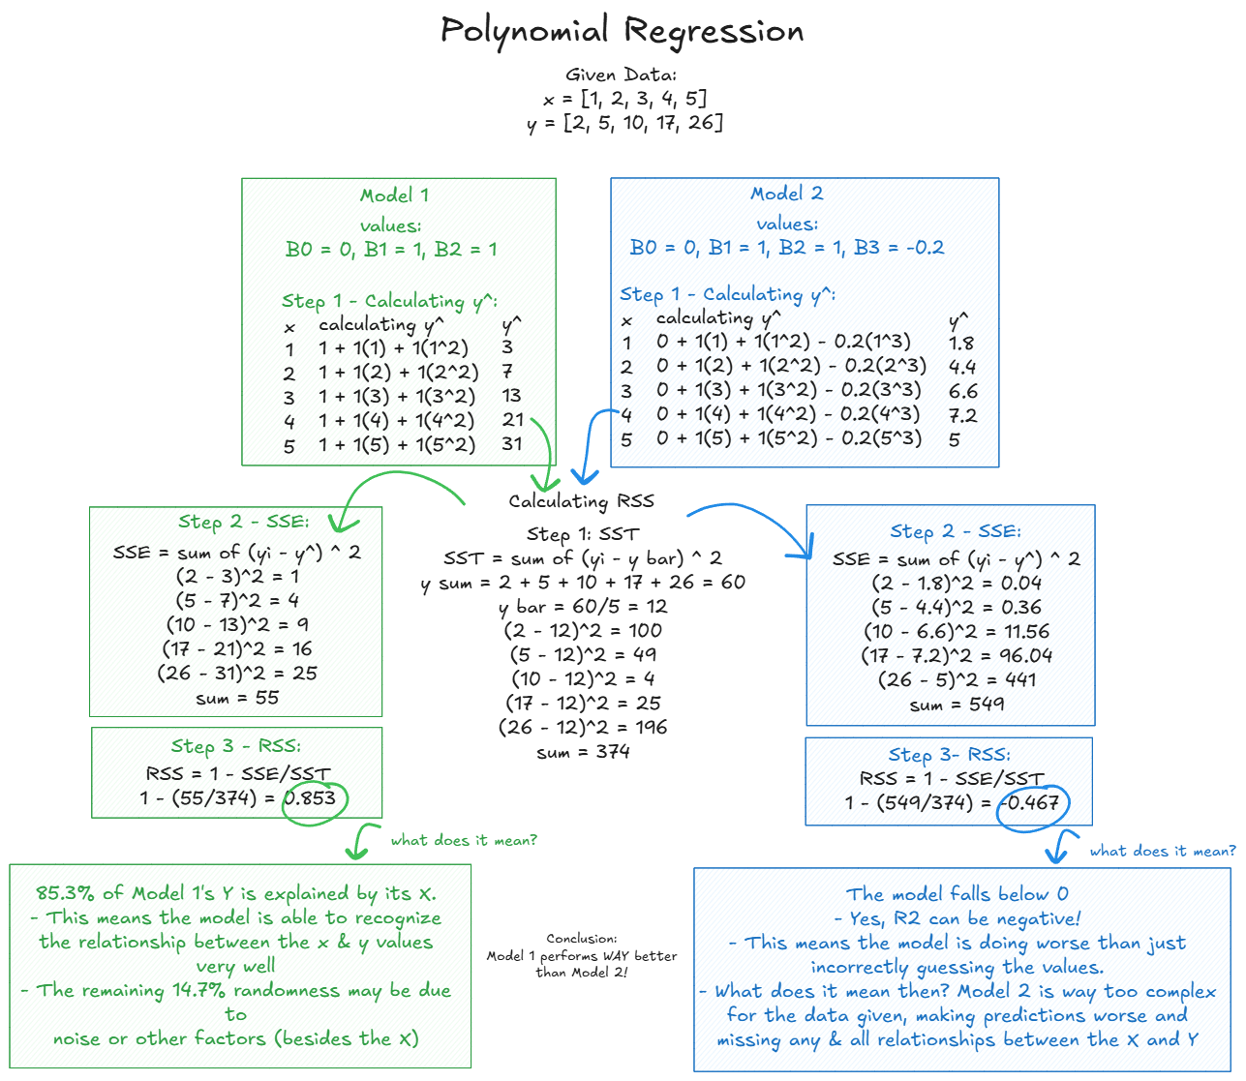

**Figure 9**

# **PART 3 – PROBLEM STATEMENT**

# **3.1 Problem Statement & Requirements**

The continuous rise in carbon dioxide (CO2) emissions have become an extensive global problem *especially* in today’s world. Many activities lead to CO2 emissions, thus I have decided to specifically focus on the agro-food sector activities, understanding their CO2 emission contributions. These emissions come from *many* different sources such as fires, food cultivation and processing, manure management, etc. These emissions lead to accelerating increase in average global temperatures, continuously warming the Earth’s atmosphere at alarming rates. Thus, this project aims to predict **Total Emissions** (the target, dependent variable) from a dataset consisting of 28 features (the independent variables).

Total Emissions accounts for the sum of the included activities that contribute to the CO2 emissions *as well as* other unknown or miscellaneous activities. Thus, the goal of this project is to create machine learning models that are able to identify the most contributing activates said total emissions, uncovering rather hidden patterns from the human eye. The outcome of these models may be able to guide those within the agro-food and environmental sector to better understand CO2 emission contributions and where to shift their focus on the potential of conducting more environmentally friendly and sustainable agro-food activities.

# **3.2 ML Algorithms: Suitable**

As already mentioned, the target **Total Emissions** is a continuous variable, thus meaning we’re working with a **regression** problem. There are *many* regression machine learning models, however, I’ve chosen the following 4 models:

1. **Polynomial Regression** [4]

* **Intro:** This model is an *extension* of simple linear regression – the difference, though, is its ability to uncover non-linear relationships between the features and the target through ***polynomial terms***. Due to its simplicity, it serves as a good baseline for regression tasks.
* **How it Works:** Its ability to model non-linear relationships is due to its usage of polynomial coefficient terms (**x2, x3, x4, etc.**) on features. The equation **y = w1x1 + b** represent a straight line (simple linear regression), while on the other hand **y = w1x1 + w2x2 + w3x3 + b** represents a *curve* (polynomial regression). So, it’s an *additional* transformation on the input (feature) to further improve the model’s ability to capture the more complex, non-linear relationships with the target.
* **Reason:** The data represents *some* linearity between the features and the target, thus the usage of a polynomial regression model will help capture this complexity. It also serves as a great baseline for other models due to its simplicity yet effectiveness.

1. **Gradient Boosting** [3]

* **Intro:** This model is an *ensemble* method, combining *multiple* weak learners (decision trees) sequentially to iteratively enhance its learning one small step at a time.
* **How it Works:** Each model Gradient Boosting train learns from the model before it, focusing on fixing its errors by reducing some loss function which is Mean Squared Error (MSE) in our case. Thus, Gradient Boosting *slowly* enhances the predictions, leading to a stable, consistent end performance.
* **Reason:** Although it’s more expensive to run due to its sequential training nature (each weak learner *has* to wait for the previous one to finish training), it is an incredibly powerful model due to its ability to capture complex relationships regardless of the data’s nature. The idea of combining weak learners that learn from one another is a powerful approach, resulting in an accurate and robust model that continues adapting to the newly learned patterns. Because capturing the underlying patterns that lead to Total Emissions may be confusing *especially* as its value includes unknown/miscellaneous emissions, the usage of weak learners that iteratively adapt to new, discovered patterns is essential to accurately predicting Total Emissions.

1. **Random Forest Regressor** [2]

* **Intro:** *Another* ensemble method that also creates multiple decision tree – *but* compared to Gradient Boosting (above) which trains weak learned on the *entire* training data, Random Forest trains its decision trees on random subsets of the data.
* **How it Works:** Random Forest trains each of its decision trees on unique, random subsets of the data to ensure diversification and robustness against overfitting. The *average* of all tree predictions is then taken and used as the final prediction.
* **Reason:** Due to its usage of random data subsets, Random Forest is a great model to use for highly dimensional data (*many* features) as its ability to rank the importance of features is *highly* valuable to determine which features contribute to Total Emissions the most.

1. **XGBoost** [5]

* **Intro:** Standing for Extreme Gradient Boosting, this model is an *advanced* extension of Gradient Boosting, including regularization methods that help prevent overfitting by adding a penalty to the model’s weight to avoid overly complex trees.
* **How it Works:** Very similarly to Gradient Boosting, it sequentially trains weak learners (decision trees), with each model learning from the other’s residual errors with the addition of regularization to prevent overly complex tree structures for the creation of a stable and efficient model. What makes XGBoost advance also is the availability of feature subsampling (similar to Random Forest), parallel computation (usage of multiple CPU cores for fastertraining), *and* early stopping (ending model training if its performance does not enhance after some iteration).
* **Reason:** XGBoost is incredibly strong to use in this problem due to the potential complex, non-linear relationship between the features and target of Total Emissions. Having access to strong techniques such as regularization and subsampling builds a model robust against overfitting. Its subsampling gives us insight into the most significant contributors to Total Emissions, similarly to Random Forest. Parallel computation *and* early stopping also gives us access to an incredibly fast and efficient model despite its advancement.

# **3.3 ML Algorithms: Comparison**

The best ML models for predicting **Total Emissions** are selected after a *thorough* evaluation of their advantages, disadvantages, and applicability to the dataset at hand. As mentioned above, the 4 best ML models found are Polynomial Regression, Gradient Boosting, Random Forest Regressor, *and* XGBoost. The following table will dive further into detail to understand the differences between these models [2][3][4][5][6]:

|  |  |  |  |
| --- | --- | --- | --- |
| **Model** | **Advantages** | **Disadvantages** | **Justification** |
| **Polynomial**  **Regression** | Simple implementation, structure, & low computational cost.  Can capture non-linear relationships between features & target.  Serves as a good regression model baseline due to its simplicity. | Too *simple* to capture more complex relationships.  Overly simplistic structure may not be suitable for complex, real world problems.  Overfitting may occur at higher degree polynomial values – especially if data size is quite *small*. | Serves as a baseline model when comparing other models (especially those more complex) to confirm their outcomes are realistic. |
| **Gradient Boosting** | Stability - *gradually* reduces errors through weak learners.  Able to capture *both* linear & non-linear relationships accurately.  Offers feature importance rankings for interpretability. | Can be easily susceptible to overfitting if hyperparameters are not tuned properly.  Computationally *expensive* especially as the data’s dimensions and size scales.  Sensitive to outliers due to its focus of minimizing the loss function. | Uncovers the more complex relationships in **Total Emissions** through models that iteratively adapt to the previous model errors. |
| **Random Forest** | Overfitting robustness due to random data subsets.  Provides clear feature importance, identifying most prominent features for prediction.  Handles highly dimensional data due to the randomly used subsets of features. | May not scale well with larger data due to number of trained trees.  Interpretability reduces as number of trees increase – structure becomes too complex.  More computationally expensive that normal decision tree models. | Provide diversification in **Total Emissions** predictions through its inherit usage of data subsets and feature subsampling while ranking feature importance for further understanding of the most important predictors. |
| **XGBoost** | Reduces overfitting with regularization and feature subsampling.  Faster training times due to parallel computation.  Promotes early stopping to avoid overfitting and unnecessary computation. | Hyperparameters may be difficult to understand and tune effectively.  Still computationally expensive compared to simpler structures (like polynomial regression).  Incorrect hyperparameter tuning can lead to overfitting. | Integrates Gradient Boosting *and* advanced optimization techniques to build robustness for overfitting and producing faster, more efficient training times. |

# **PART 4 – MODEL DEVELOPMENT**

# **4.1 Dataset: Details**

To further understand the data we’re working on this, the following sections will cover extensive details about the dataset I’ve used for this project.

1. **Intro**

* The **Agri-Food CO2 Emissions** dataset, as previously mentioned, is a collection of data detailing emissions from difference agro-food related activities. Through this, we are able to predict **Total Emissions** which is a sum of the accounted for activities’ CO2 emissions within the data as well as other unknown and miscellaneous source. Thus, this prediction will allow us to identify the *primary* sources of total CO2 emissions.

1. **Source** [8]

* This dataset was found and sourced from **Kaggle.**

1. **Method of Collection** [8][9][10]

* This dataset was created by the merging and preprocessing of around 12 separate datasets from the Food and Agriculture Organization (FAO) *and* the Intergovernmental Panel on Climate Change (IPCC) regarding agro-food activity CO2 emissions. Together, the **Agri-Food CO2 Emissions** dataset becomes compromised of agriculture and food activities alongside their emission estimates and temperature increase impact.

1. **Key Attributes**

* The dataset contains a total of **29** attributes
* **Independent Variables, Features:**
  + **Environmental:** Emissions related to environmental activities such as fires, food cultivation, pesticides, and organic soils.
  + **Humanly:** Emissions related to human activities regarding food such as transport, household and retail consumption, manure, electricity and energy use, and industrial processes.
  + **Waste:** Emissions regarding food waste such as waste disposal and food packaging.
  + **Area:** The country of the recorded emissions.
  + **Year:** The year of the recorded emissions.
  + **Population:** Simple values for rural, urban, and total (as well as female and male) populations in the area.
  + **Temperature:** Increase of average temperature in degrees Celsius.
* **Dependent Variable, Target**
  + **Total Emissions**, representing the sum of the total emissions from the features *and* other unknown variables, is what we aim to predict in this project.

1. **Size**

* **Records:** 6965 rows (almost 7000)
* **Attributes, 29:** 28 features *and* 1 target (Total Emissions)

1. **Domain**

* As previously mentioned, this dataset is concerned with the **agri-food** domain and its CO2 emissions. According to the dataset, agri-food emissions are responsible for over 60% of the Total Emissions (which accounts for *all* greenhouse gas emissions from sources other than agri-food activities as well).

# **4.2 Data Splitting**

Although the data we have is transformed and cleaned for general use, it is still *not* ready to be immediately used for machine learning models as there are *many* preprocessing steps it must go through first. Therefore, here are the preprocessing and splitting steps I’ve taken in my project (alongside screenshots of the *actual* code) to properly demonstrate my strategy.

1. **PREPROCESSING:** The data is in need of some transformations to ensure it’s completely clean and ready to be taken to the model preparation step after.
   1. **Column Names:** Upon inspecting the column names, I’ve noticed they do not have a consistent naming system (some were capitalized, some weren’t), special characters, and a lack of underscores between words made it difficult to select and access column names. To solve this problem, I used both the string replace and rename functions to change all column name into a consistent, straightforward format.

* **Checking Column Names:**

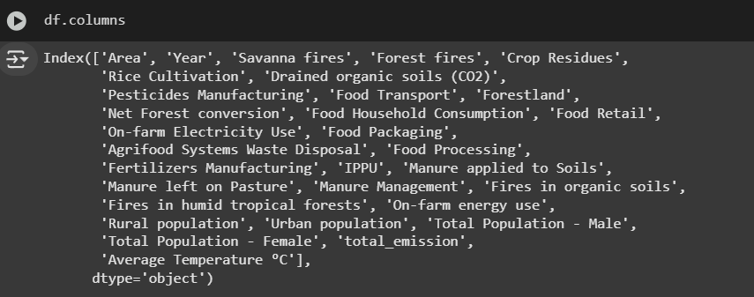

* **Renaming Using Str Replace Function:** The code below ensures that each word in the column name is capitalized, brackets and dashes are removed, *and* spaces are replaced with an underscore for consistent format and ease of access and use.

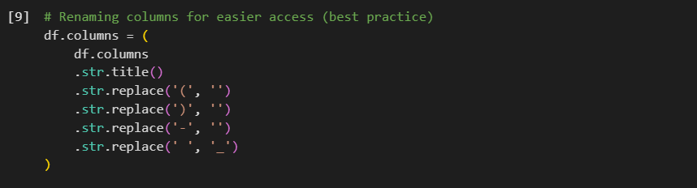

* **Manually Renaming:** Some column names as observed below were easier to rename manually, so I used the rename function using a dictionary.

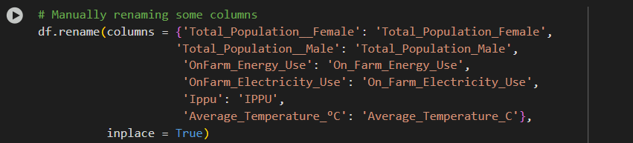

* ***Column Names* Result:** Now, the column names are clear, consistent, and easy to use.

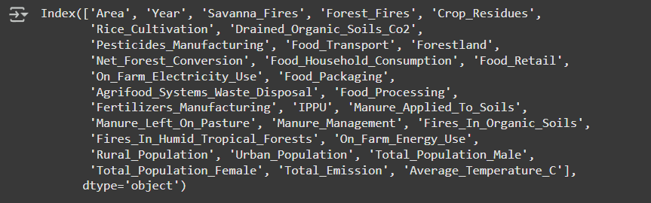

* 1. **Filling Nulls:** It’s important to handle missing values for *all* features. The dataset had around 7000 null values, and I’ve used 3 techniques to fill these null values according to their data skewness by creating a histogram to visualize the data nature: forward fill for *left* skewed data, backward fill for *right* skewed data, and mean for any leftover null values.
* **Checking Nulls:**

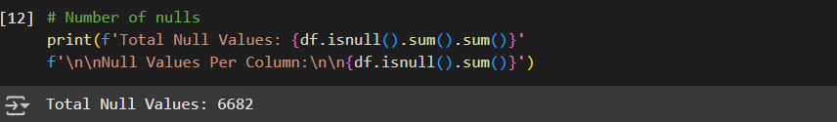

* **Histogram Plot:**

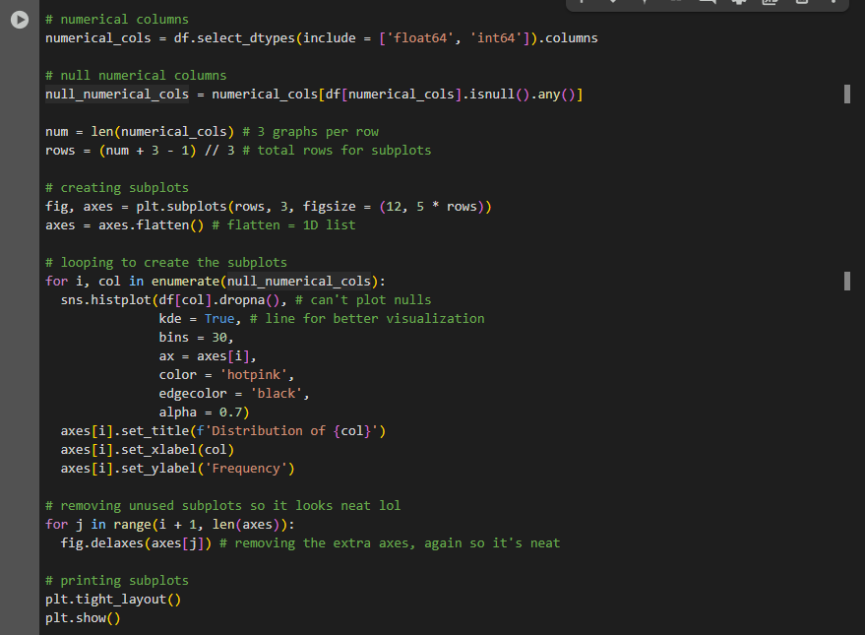

* ***Histogram Plot* Results:** As observed in the histograms below, 10 features are skewed *left* while only 1 feature is skewed *right*. Therefore, I will apply the forward and backward fill techniques as appropriate in the next step.

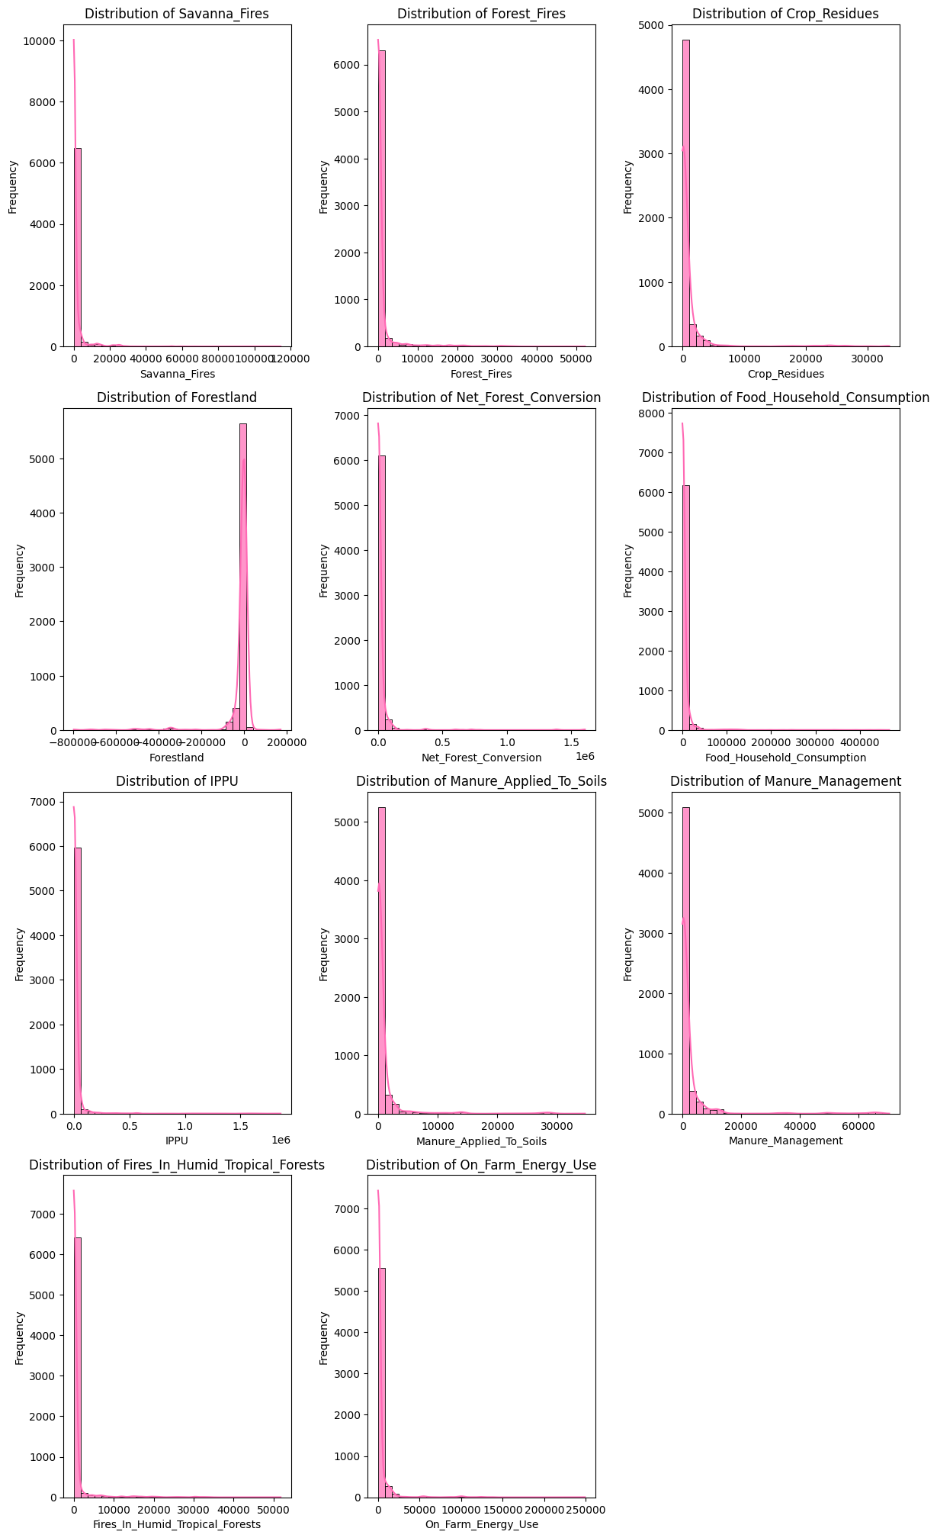

* **Forward & Backward Fills:**

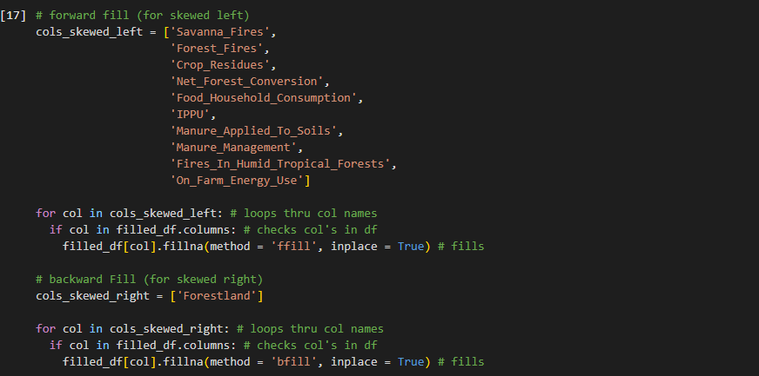

* **Checking Nulls (After):** As observed below, there are *still* some null values left and they all belong to *one* single feature.





* **Filling By Mean:**



* **Checking Nulls (After):**

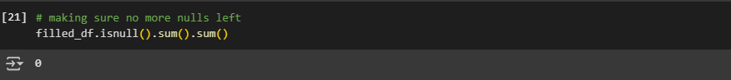

* ***Histogram Plot* Results (After Filling):** This step is to *ensure* the distribution of the features’ values that were filled has not been changed to avoid misinformation. As we’ll observe in the plot below, comparing it to the original histogram *earlier*, the distribution has not changed – thus, handling the missing values was a success.

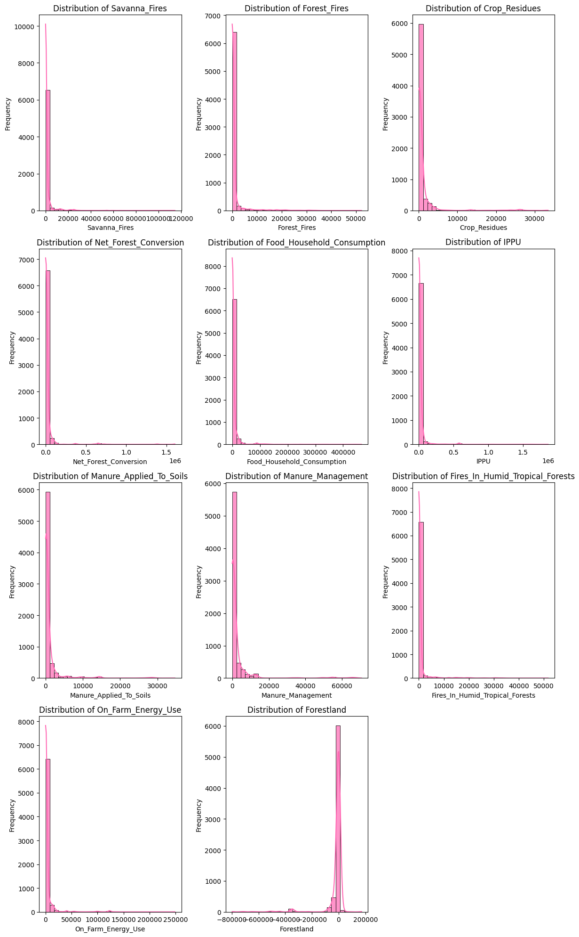

* 1. **Label Encoding:** Some plots require features to be *numerical* (such as the heatmap in the following step), thus applying label encoding (which transforms any categorical column to a numerical column) is essential.

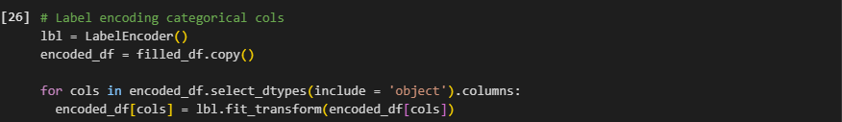

* 1. **Eliminating Multicollinearity:** When working with linear regression models (such as polynomial regression in our case), eliminating multicollinearity is crucial. Multicollinearity is a feature having a high correlation (usually a threshold of 0.7) with *another* feature – this acts as redundancy as the model will see these features as the *same*.
* **Correlation Matrix, Heatmap:**

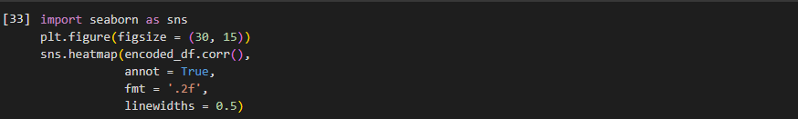

* ***Heatmap* Results:** As we see, this dataset is **heavily** multicollinear, thus eliminating at a threshold of 0.7 leads to removing *almost every* feature.

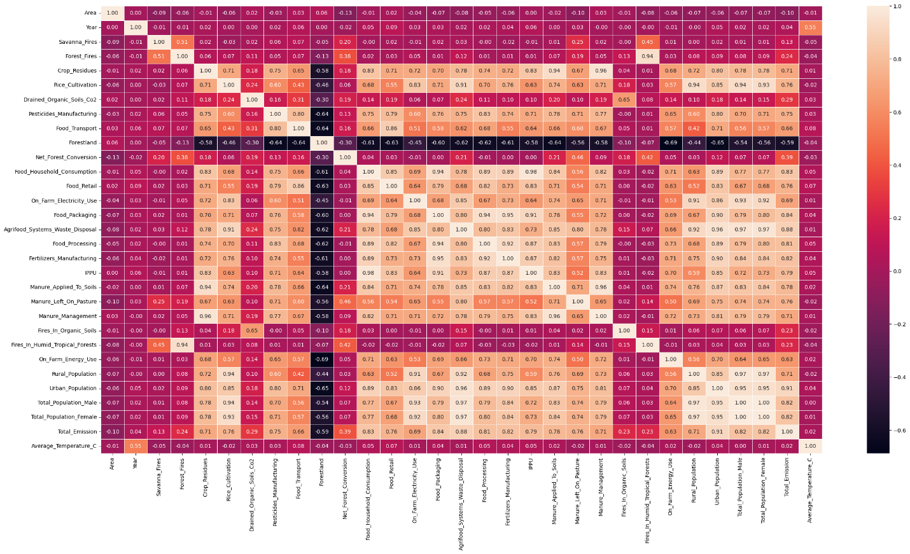

* **Removing Low Correlation:** The first step is to remove features that have a low correlation with our target **Total Emissions** as they won’t be strong predictors.

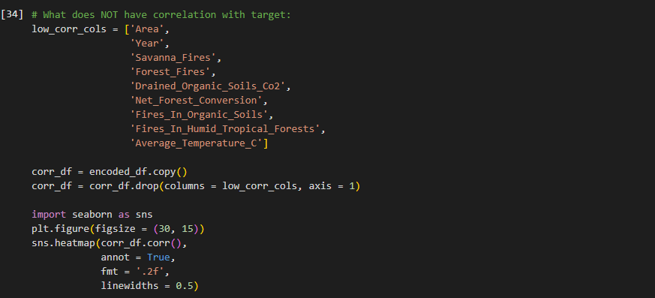

* **Correlation Matrix, Heatmap(After):** With the below image, we can *truly* see how badly multicollinear this data is.

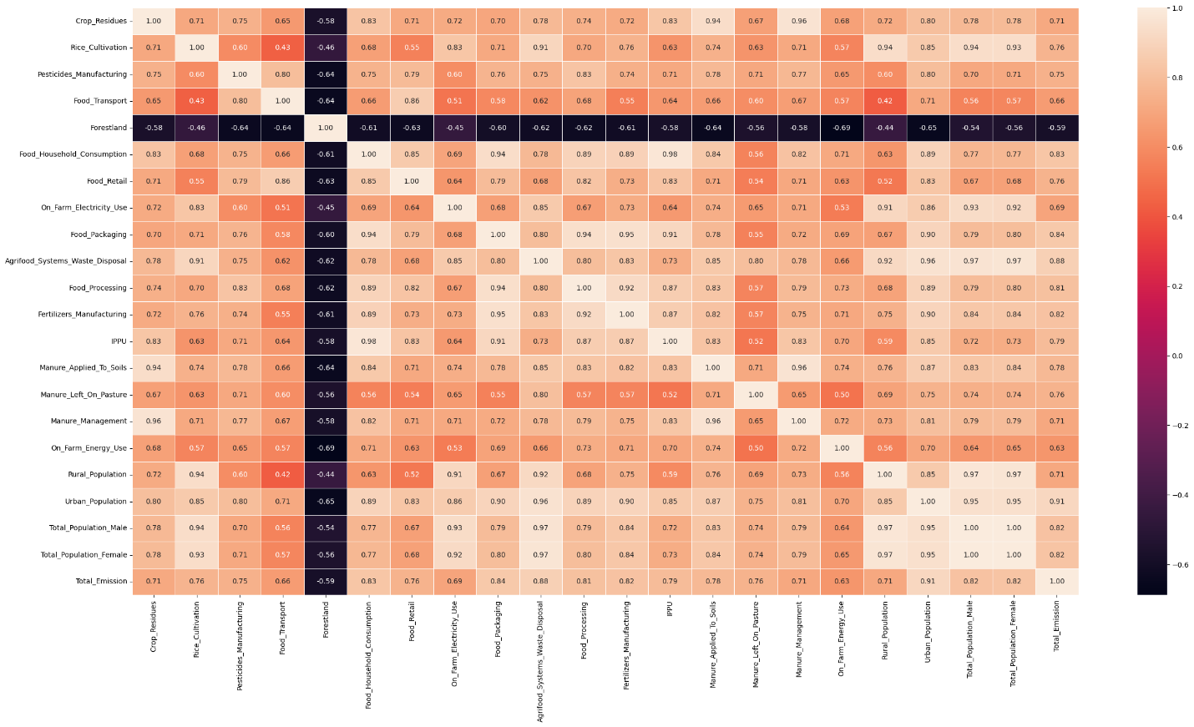

* **Threshold of 0.85:** After inspecting the heatmap above, I’ve decided a threshold of 0.85 will remove *insanely* high correlations while still maintaining a number of the features. This will obviously not fully remove multicollinearity as the nature of the dataset is quite difficult to deal with.

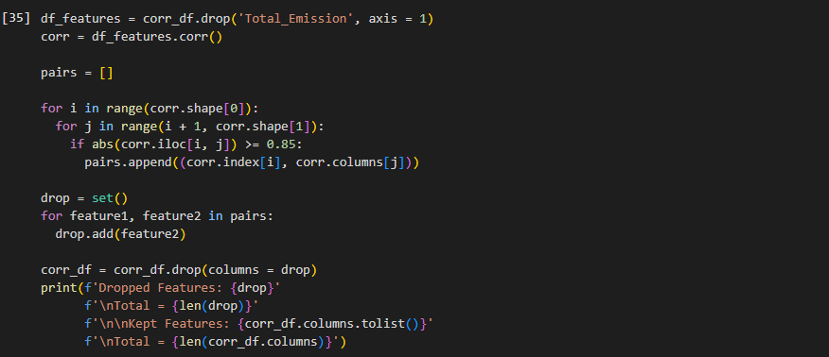

* **Correlation Matrix, Heatmap (After):** As observed below, there obviously still exists multicollinearity, however it is *much* better than the previous state of the data. In addition, besides the Polynomial Regression model, the remaining 3 models (Gradient Boosting, Random Forest, *and* XGBoost) can handle this multicollinearity inherently.

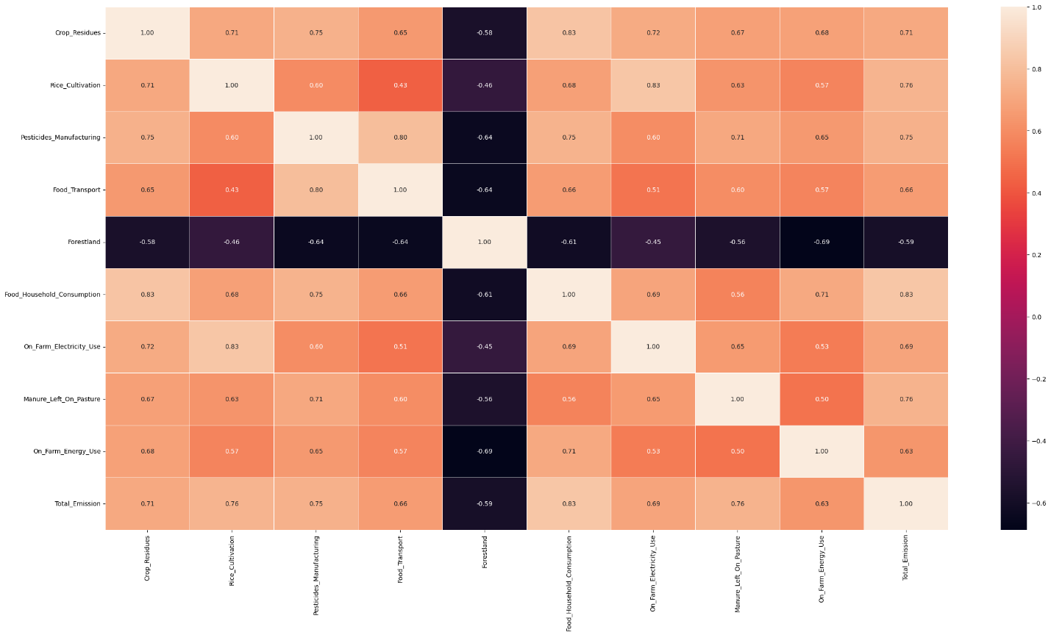

* 1. **Scaling:** Some regression models, especially linear regression models like Polynomial Regression, need values to be scaled – keeping the values as is may produce bias due to their large range [11]. This way, all features in the dataset can directly compete with another fairly.



1. **SPLITTING:** To prepare the data for machine learning models, it must be split into train and test subsets – the training data is what the model uses to *learn* and recognize the patterns, and the testing data is what it uses to test its knowledge and predict the values. An additional subset, validation, is used in our project – validation subsets act as *internal checkpoints* within the training subsets to ensure the model is learning properly.
   1. **Train – Test Split:** The data we’re working with will be split into 80% training and 20% testing size. Because our data is in chronological order by year, I used the **shuffle** parameter, so the records are *not* in order. The **random state** parameter ensures control and consistency of randomness every time the split occurs.

* **Scaled Data Split:** This will be used for Polynomial Regression for the reason I’ve mentioned earlier.

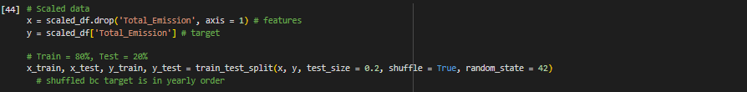

* **Unscaled Data Split:** This will be used for Gradient Boosting, Random Forest, *and* XGBoost as they perform better with the original data

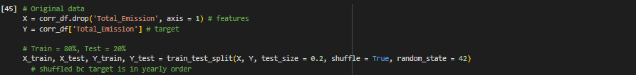

* 1. **Validation Split (Grid Search):** Rather than manually creating the validation splits, this can be done using Grid Search Cross Validation (cv) with cv = 5. What this means is at each parameter combination, the model is trained using 4 folds then its learning is validated on the 5th and last fold. In other words, 4/5 of the training data (80%) is truly used for training and 1/5 of the training data (20%) is used for validation. This ensures the model is *not* overfitting and is learning the training data effectively.

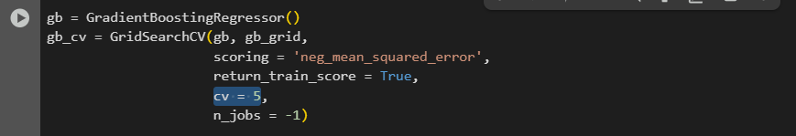

# **4.3 Model Training**

Once the preprocessing and splitting of the data is complete, we can begin initializing and training the machine learning models to find the *best* hyperparameter combination and make predictions for our target variable **Total Emissions** using them. Here are the detailed steps I’ve taken to train my machine learning models:

**Grid Search:** Before beginning *any* step, I’ve imported GridSearchCV as our gateway to smoothly training the model on *multiple* hyperparameter combinations until it finds the one combination with the most optimal results, as well as the usage of cross validation to ensure the model is *properly* learning the data.



**Time:** In order to compute how long each model takes during its fitting process, I’ve important the **time** library.



1. **POLYNOMIAL REGRESSION:** The following information includes all the steps I’ve taken to create my Polynomial Regression model.
   1. **Importing Libraries:** Because a Polynomial Regression model is simply a Linear Regression model with the addition of polynomial degrees, it’s crucial to import Linear Regression and Polynomial Features from sklearn. The usage of a pipeline, also from sklearn, will allow us to combine the transformation from Linear to Polynomial Regression in one, smooth step.
   2. **Grid:** The following is a *dictionary* which defines the different hyperparameter values (polynomial degree) we’ll be using to fit and predict the model on using GridSearchCV.



* 1. **Pipeline Initialization:** The following block of code is how we initialize pipeline for the creation of a Polynomial Regression model.

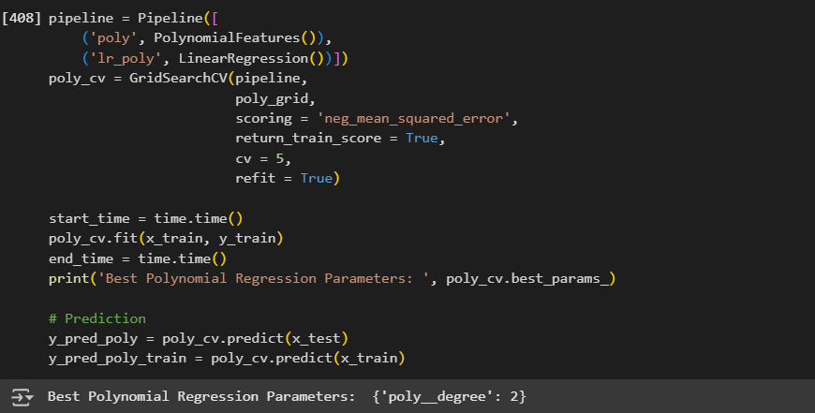

* 1. **Model Initialization:** This following block of code initializes our model using GridSearchCV.
* **Pipeline and Hyperparameter Grid:** For automatic polynomial model transformation and fitting with the degree values.
* **Scoring Metrics:** Set to ‘neg_mean_squared_error’ as the standard metrics.
* **Cross Validation:** Initialized as ‘cv = 5’, meaning the training portion will be divided into 5 folds – for 5 iterations, 4 folds will be used for *actual* training, and 1 remaining fold will be used to validate the model’s performance.
* **Return Train Score:** Set to True, which gives us access to a value called ‘mean_test_score’ or the validation score on the last fold during the training process for each hyperparameter combination.
* **Refit:** Set to True, gaining us access to best estimator, which is *similar* to best params and gives us the best hyperparameter combination of the model, but we *do not* need to refit the model when using best estimator – it’s automatically already fitted, saving us time and computation power.



* 1. **Model Fitting:** As observed below, this block of code covers the process of model fitting, which is the training of the model on the training data by adjusting its parameters with the goal of minimizing loss.
* **Time:** Start and end times are calculated before and after the fitting of the model to calculate the total time it takes. This can help us analyze how efficient the algorithm really is for use.
* **Best Params:** As briefly mentioned before, best params shows the best hyperparameter combination GridSearchCV has found for the model. I simply used the print function to know which combination turned out to be the best.

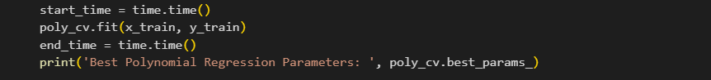

* 1. **Model Prediction:** Once the fitting process is over, the model can now predict the target variable **Total Emissions**. We’re aiming to predict for x test as it’s what gives us y test. *However*, I’ve also predicted x train (the data the model has already seen and trained on) to double check its learning.



And this sums up all the steps I’ve taken to training the Polynomial Regression model. I will provide the codes for the remaining algorithms, however without any additional explanation (unless needed) as everything above will apply to the upcoming models as well.

1. **GRADIENT BOOSTING:** The following information includes all the steps I’ve taken to create my Gradient Boosting model.
   1. **Importing Libraries:**



* 1. **Grid:**

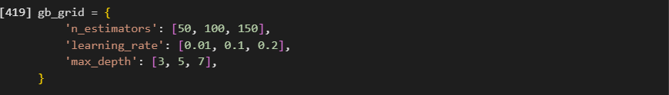

* 1. **Model Initialization:**

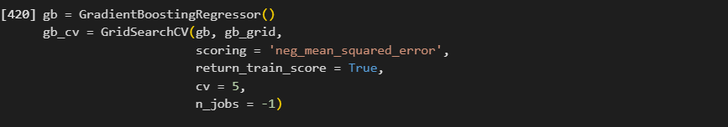

* 1. **Model Fitting**

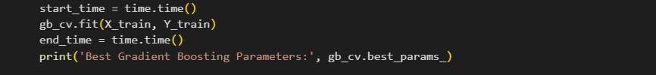

* 1. **Model Prediction**



1. **RANDOM FOREST REGRESSION:** The following information includes all the steps I’ve taken to create my Random Forest Regression model.
   1. **Importing Libraries:**



* 1. **Grid:**



* 1. **Model Initialization:**

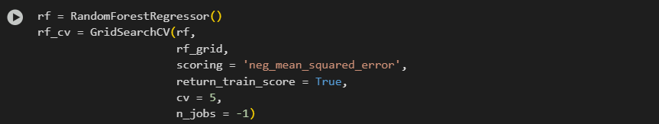

* 1. **Model Fitting:**

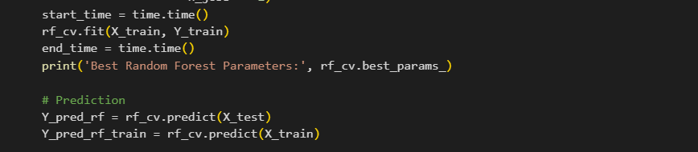

* 1. **Model Prediction:**



1. **XGBOOST:** The following information includes all the steps I’ve taken to create my XGBoost Regression model.
   1. **Importing Libraries:**

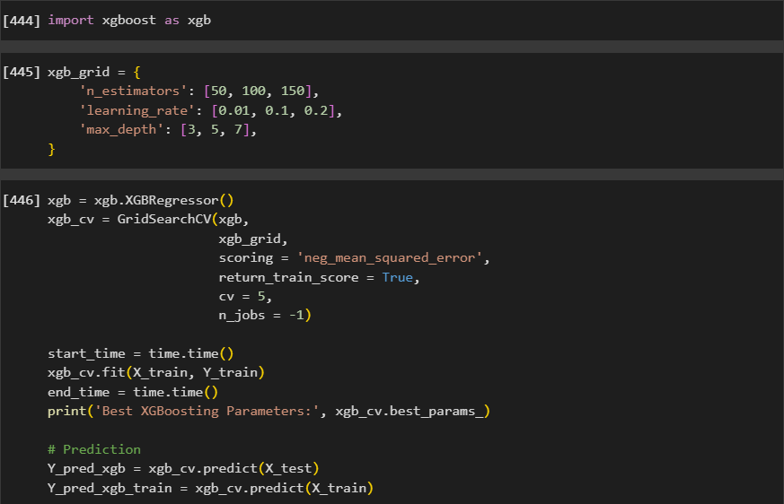

* 1. **Grid:**



* 1. **Model Initialization:**



* 1. **Model Fitting:**



* 1. **Model Prediction**



And that brings *all* the steps I’ve taken to train all 4 models to an end.

# **4.4 Model Training: Details**

Machine learning models can be trained with *hyperparameters*, which can manipulate the configuration and structure of the model. Different models can have similar *and* different hyperparameters, but in the end it’s crucial to choose the best combination of values to output the best possible results. Using Grid Search, machine learning models can train in a range of selected hyperparameter combinations to find the best one [12]. The following table summarizes the algorithms I used, their considered hyperparameters, and their value.

|  |  |  |  |
| --- | --- | --- | --- |
| **HYPERPARAMETER** | **MODELS** | **DESCRIPTION** | **VALUES** |
| polynomial degree | **Polynomial Regression** | The degree of the polynomial terms for *each* feature to capture the complex, non-linear relationships (between the feature and the target) | 2, 3, 4, 5 |
| n estimators | **Gradient Boosting, Random Forest, XGBoost** | The number of weak learners (decision trees) that will be used in the model. | 50, 100, 150 |
| max depth | **Gradient Boosting, Random Forest, XGBoost** | Maximum depth of *each* tree, directly affecting the model’s ability to recognize and capture complicated patterns. | 3, 5, 7 |
| learning rate | **Gradient Boosting & XGBoost** | Each tree’s contribution to the *final* model prediction. Random forest does not have this as it takes the ***average* of all** trees. | 0.01, 0.1, 0.2 |
|  |  |  |  |
| **Model** | **Best Combination** | | |
| **Polynomial Regression** | polynomial degree: **2** | | |
| **Gradient Boosting** | learning rate: **0.2**  max depth: **7**  n estimators: **50** | | |
| **Random Forest** | max depth: **7**  n estimators: **150** | | |
| **XGBoost** | learning rate: **0.2**  max depth: **5**  n estimators: **150** | | |

# **PART 5 – MODEL EVALUATION**

# **5.1 Performance Metrics**

In order to understand if the trained machine learning model is successful, metrics are used to evaluate the model’s performance. Considering I’m working on a **regression** problem to predict the target of **Total Emissions**, I’m using the following 4 metrics:

|  |  |  |  |
| --- | --- | --- | --- |
| **METRIC** | **DEFINITION** | | **JUSTIFICATION** |
| **MSE:**  **Mean Squared Error** | Measures the average **squared** error (difference between the prediction and actual values. Squaring the error does lead to heavily penalizing larger errors.  Equation:  **MSE = 1/n (yi - ypred)** | Often used as the go to metric to assess a model’s loss. It allows us to truly understand how well a model predicts especially due to squaring the errors, penalizing larger errors. | |
| **RMSE:**  **Root Mean Square Error** | The square root of the MSE. Compared to the MSE, the root calculates the error in the same units of the target, providing better interpretability.  Equation:  **RMSE = √1/n (yi – ypred)** | Presents the MSE in the *same* units as the target, allowing us to interpret the errors easily. | |
| **MAE:**  **Mean Absolute Error** | Measures the average **absolute** error (the difference between the prediction and actual values). Gives us how far the prediction was from the actual value *without* any direction.  Equation:  **MAE = 1/n | (yi - ypred) |** | A simple metric that allows us to see the *general* error making of the model *regardless* of its direction – each error is treated the same, and larger errors are not penalized more as there is no square. | |
| ***Note:*** The lower the value, the more accurate the model’s predictions are. | | | |
| **R2:**  **Coefficient of Determination** | Measures a model’s ability to capture the variation of values using the features. In other words, it is the *proportion* of variance in the target explained by the input of the model.  Equation:  **R2 = 1 – (RSS/TSS)** | Helps us assess a model’s *general* sense of the data’s pattern and variability using the input features. | |
| R2 closer to 1 | R2 closer to 0 | R2 is negative | |
| The better the model can correctly predict *and* explain the data’s variability according to the input features. | The poorer the model’s performance is – it is quite unable to correctly predict the data’s values *and* its patterns. | The model is **not just** incorrectly predicting values – it’s *completely* missing the pattern of the data. | |

# **5.2 Three Way Split: Best Model & Prediction**

As briefly mentioned before, preparing our dataset by splitting it into training and testing sets is crucial as machine learning models learn data patterns from the training set and applies this knowledge to predict the testing test. However, there is also a third set called the **validation set** which in our case is essentialto find the best performing hyperparameter combination for each algorithm using GridSearchCV. In short, a validation set is an unseen subset of the training set that is used as a checkpoint to evaluate the model’s performance. In other words, this validation subset ensures the model is able to generalize unseen data for future predictions.

**Cross Validation Process:** Because our CV (cross validation) is initialized as 5 in GridSearchCV across all models, this means the training data is divided into 5 folds – each iteration will use 4 different folds for training and the last remaining fold will be used to validate the training. This ensures the reduction of potential bias when using a specific validation set, making use of all available data. In the end, an average of the model’s performance is taken to calculate its average performance of generalization. This process is repeated for *all* hyperparameter combinations – the highest performing combination is chosen as the **best estimator**. Here’s its visualization:

|  |  |  |
| --- | --- | --- |
| **CV (Cross Validation) = 5** | | |
| **Iteration** | **Training** | **Validation** |
| **1** | S1, S2, S3, S4 | S5 |
| **2** | S1, S2, S3, S5 | S4 |
| **3** | S1, S2, S4, S5 | S3 |
| **4** | S1, S3, S4, S5 | S2 |
| **5** | S2, S3, S4, S5 | S1 |

The screenshots below will dive into the details of the validation set initializations and the *best* performing models for each algorithm as well as their predictions on the test sets.

1. **Polynomial Regression:** The following information includes all the steps I’ve taken to 3 way split the data for my Polynomial Regression model, find its best hyperparameter value, and use it to predict on the testing subset.
   1. **Validation Subset:** As previously mentioned, the use of GridSearchCV automatically and internally handles the validation subset process through the initialization of its cv parameter as 5, dividing the training data into 5 folds.

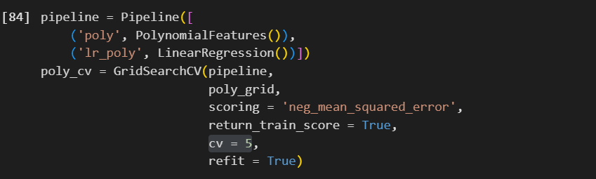

* 1. **Best Estimator [Polynomial Degree = 2]:** This was the model’s best estimator after initializing and fitting it using GridSearchCV.

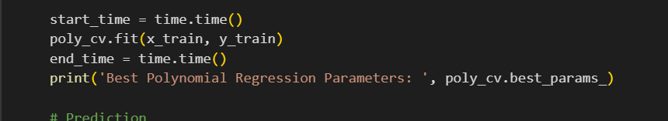



* 1. **Test Prediction:** Once the best estimator has been found, the model then predicts on the testing data (using said best hyperparameter value).

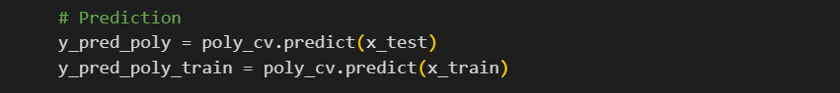

* 1. **Prediction Results:** Once themodel has predicted on the testing set, the metrics (MAE, MSE, RMSE, and R2) I explained here are used to evaluate the model’s performance.

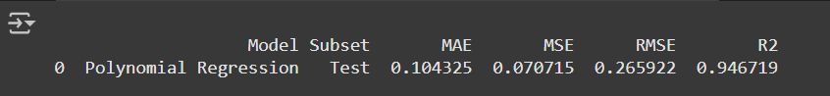

|  |  |  |
| --- | --- | --- |
| **Discussing Prediction Results: POLYNOMIAL REGRESSOIN** | | |
| **Metric** | **Values** | **Meaning** |
| **MAE** | **0.1** | On average, the model’s prediction is 0.1 units away from the actual values, which is low and depicts accurate predictions by the model. |
| **MSE** | **0.07** | A value of 0.07 shows that there are minimal large errors (as the MSE penalizes larger errors due to the squaring), demonstrating an effective model. |
| **RMSE** | **0.26** | The root of the MSE, reverting the values to the target variable’s (**Tota Emissions**) units (whose values range in the thousands). This value of 0.27 is considered *very* small, meaning the model is accurately predicting the target. |
| **R2** | **0.94** | An R2 of 0.94 means the model can explain 94% of the variability and pattern in the target variable, proving a great overall performance. |
| **Final Thoughts** | | |
| Polynomial Regression shows great performance with low errors and great explanatory capabilities. | | |

And this sums up all the steps I’ve taken to split 3 way, train, and predict the Polynomial Regression model. I will provide the codes for the remaining algorithms, however without any additional explanation asides from the results, as everything above will apply to the upcoming models as well.

1. **Gradient Boosting:** The following information includes all the steps I’ve taken to 3 way split the data for my Gradient Boosting model, find its best hyperparameter combination values, and use it to predict on the testing subset.
   1. **Validation Subset:**

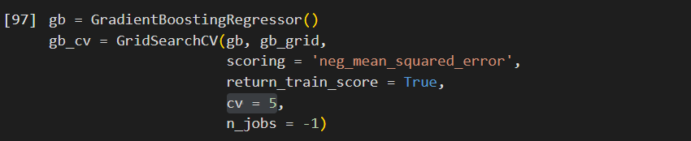

* 1. **Best Estimator [Learning Rate = 0.2, Max Depth = 7, N Estimators = 50]:**

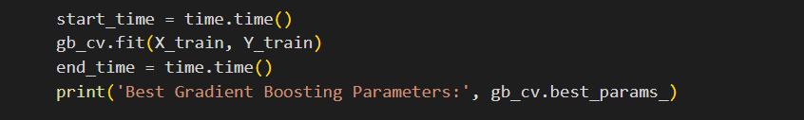



* 1. **Test Prediction:**



* 1. **Prediction Results:**



|  |  |  |
| --- | --- | --- |
| **Discussing Prediction Results: GRADIENT BOOSTING** | | |
| **Metric** | **Values** | **Meaning** |
| **MAE** | **7943** | On average, the model’s predictions are off the actual values by 7943 units, which is quite high (*compared to Polynomial Regression*) |
| **MSE** | **1.7e+0.9** | Due to the larger error, the value suggests the model has made some large errors during its prediction. |
| **RMSE** | **41,633** | Similarly to the MSE, this value suggests there are some larger errors made presented in the target variable’s (**Total Emissions**) original units. |
| **R2** | **0.974** | Despite the relatively large errors, the R2 value of 0.974 depicts the model can explain 97.4% of the target’s variability and pattern which means strong prediction capabilities. |
| **Final Thoughts** | | |
| Although the model sees some larger errors in its predictions (according to the MAE, MSE, *and* RMSE), its high R2 *still* suggests a highly effective model as it proves great predictive value. | | |

1. **Random Forest Regression:** The following information includes all the steps I’ve taken to 3 way split the data for my Random Forest Regression model, find its best hyperparameter combination values, and use it to predict on the testing subset.
   1. **Validation Subset:**

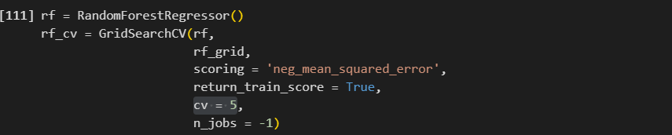

* 1. **Best Estimator [Max Depth: 7, N Estimators = 150]:**

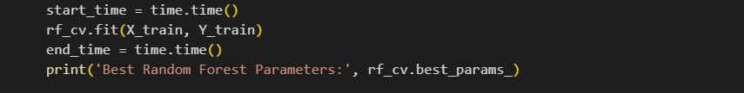



* 1. **Test Prediction:**



* 1. **Prediction Results:**



|  |  |  |
| --- | --- | --- |
| **Discussing Prediction Results: RANDOM FOREST REGRESSOR** | | |
| **Metric** | **Values** | **Meaning** |
| **MAE** | **19,570** | On average, the model’s predictions are off the actual values by 19,750 units which is an even higher error compared to *both* Polynomial Regression & Gradient Boosting. |
| **MSE** | **2.34e+0.9** | Due to the higher MSE value, the Random Forest sees larger errors which are heavily penalized. |
| **RMSE** | **48,443** | Similarly to the MSE, this value suggests there are some larger errors made presented in the target variable’s (**Total Emissions**) original units. |
| **R2** | **0.966** | Despite the high errors, the R2 value of 0.966 depicts the model can explain 96.6% of the target’s variability and pattern which means strong prediction capabilities (but lower than Gradient Boosting due to the larger errors). |
| **Final Thoughts** | | |
| The model struggles with large prediction errors according to its high error metrics but has a decent explanatory power (R2) similar to other models. | | |

1. **XGBoost:** The following information includes all the steps I’ve taken to 3 way split the data for my XGBoost model, find its best hyperparameter combination values, and use it to predict on the testing subset.
   1. **Validation Subset:**

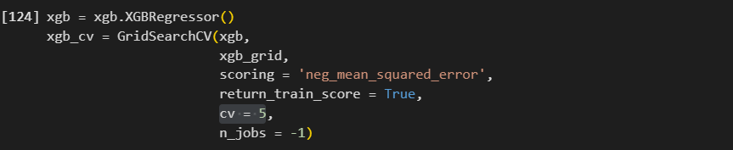

* 1. **Best Estimator [Learning Rate = 0.2, Max Depth = 7, N Estimators = 150]:**

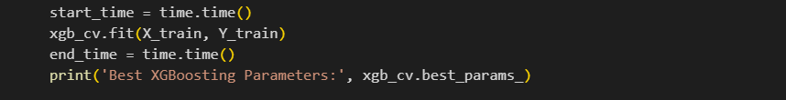



* 1. **Test Prediction:**



* 1. **Prediction Results:**

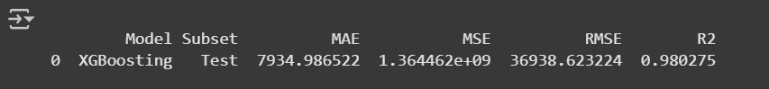

|  |  |  |
| --- | --- | --- |
| **Discussing Prediction Results: XGBOOST** | | |
| **Metric** | **Values** | **Meaning** |
| **MAE** | **7934** | The model performs better than the Random Forest & Gradient Boosting models with predictions of 7934 units *on average* away from the actual values. |
| **MSE** | **1.36e+0.9** | When compared to the Random Forest & Gradient Boosting models, the MSE shows a relatively smaller squared error, indicating fewer large errors. |
| **RMSE** | **36,938** | Similarly to the MSE, this value suggests there are some larger errors made presented in the target variable’s (**Total Emissions**) original units, but fewer than the Random Forest & Gradient Boosting models. |
| **R2** | **0.98** | The model's R2 score of 0.98 indicates that it performs the best among the models, explaining 98% of the variability in the target variable. |
| **Final Thoughts** | | |
| When compared to other ensemble models, XGBoost performs the best with its minimal errors and exceptional explanatory power (R2 = 0.98). However, Polynomial Regression has more accurate predictions due to its lower error metrics. | | |

And that brings *all* the steps I’ve taken to split, find the best estimator, and predict test data on all 4 models to an end.

# **5.3 Results: Reliability**

It’s important to not just output metric calculations for outcomes of the machine learning models but also understand whether the model is reliable to base our knowledge off or not. In order to analyze its reliability, it’s crucial we understand whether our resulting model is underfitting, overfitting, or balanced. Let’s explore the difference between the 3:

1. **Underfitting:** The model is too simplistic, failing to capture most if not all of the data’s patterns, thus having high bias and low variance – it often favors *some* point, and its prediction plot and values have no variability.
2. **Overfitting:** The model is too complex, fitting the data’s patterns almost *too* perfectly, thus having low bias and high variance – its predictions are often almost exact, and its plot pattern follows the observed points *perfectly*.
3. **Balanced:** The model provides a well balance between both bias and variance, predicting seen data quite accurately and having the ability to generalize new, unseen data quite well, thus proving to be a reliable model for the usage of future knowledge.

I’ve created 2 functions: **splittLoss** *and* **splitLossVal** which calculate and plot the model’s prediction loss (MSE) for training vs. testing and training vs. validation respectively. Both functions will subset the data into different training data sizes (from 10% to 90%) and predict from x train using the model’s best parameters from the previous model fitting. For the testing comparison, the model will also predict from x test. While for the validation comparison, using sklearn’s cross validation score library, the function will calculate the cv score at each split (each with 5 folds, same as GridSearchCV for consistency). The resulting plots will guide us to understanding whether the machine learning model is underfitting, overfitting, or balanced. Generally speaking, training vs. validation loss is used to diagnose the model’s health, however aggregating its results with training vs. testing loss is also crucial to check how the model performs on uncontrolled environments. Let’s explore the resulting plots for all 4 used algorithms:

1. **Polynomial Regression**

|  |  |  |
| --- | --- | --- |
| **Hyperparameter Combinations (In Order)** | | |
| **Combination:**  **[polynomial degree]** | **Training Performance** | **Validation Performance** |
| ***2*** | -0.046580 | -5.555950e-02 |
| 3 | -0.030694 | -1.314020e+00 |
| 4 | -0.022795 | -2.572801e+06 |
| 5 | -0.000962 | -2.938627e+16 |

* 1. **Training vs. Validation Plot:** As seen in the plot below, the training loss is quite stable, showing very low errors across all training sizes. The validation loss on the other hand starts *incredibly* high and reduces dramatically at train size 0.2, eventually stabilizing with the training loss values as the train size increases. This indicates the Polynomial Regression model is learning the data quite well and is able to generalize as the training and validation loss values are quite close with no major gaps.

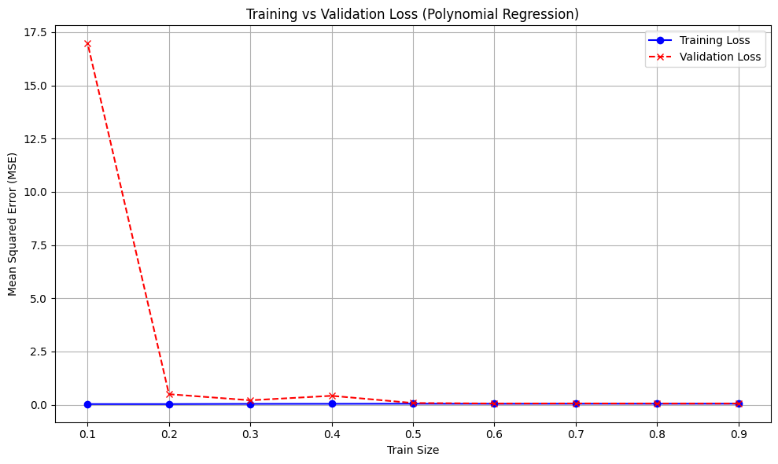

* 1. **Training vs. Testing Plot:** Despite the consistent and stable training vs. validation loss values above and the stable training loss values in the plot below, the Polynomial Regression model fails to generalize new data predictions as the train size grows.

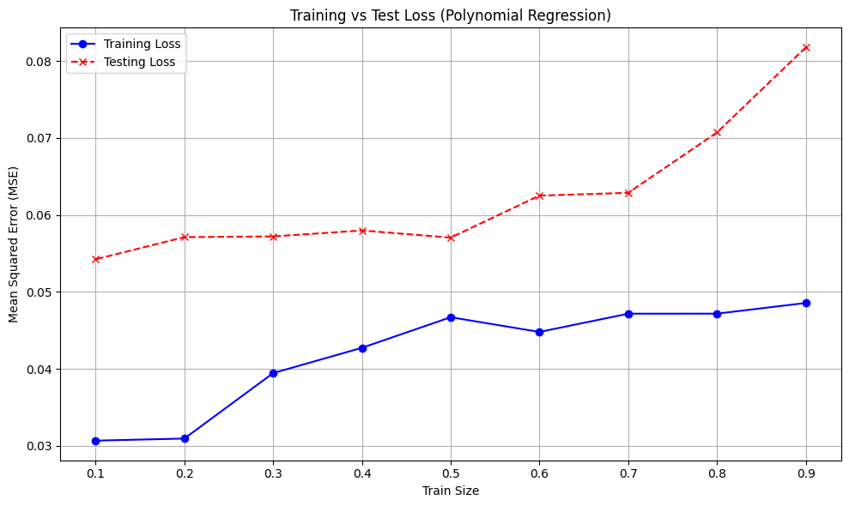

* 1. **Understanding – Well Balanced:** With little difference between training and validation losses, Polynomial Regression is a well-balanced due its effective ability to generalization. However, the model *does* face issues in generalizing test data as shown through the increase of test loss with larger datasets. So, although the model performs exceptionally well in validation, the increased errors in the testing predictions show the model lacks some accuracy and may not scale well with new and larger data. However, generally speaking, the model remains effective and reliable.

1. **Gradient Boosting**

|  |  |  |
| --- | --- | --- |
| **Top 5 Hyperparameter Combinations (In Order)** | | |
| **Combination:**  **[learning rate, max depth, n estimators]** | **Training Performance** | **Validation Performance** |
| ***0.2, 5, 150*** | -1.189139e+07 | -4.612947e+08 |
| 0.2, 7, 150 | -9.724478e+05 | -4.934036e+08 |
| 0.1, 5, 150 | -4.434965e+07 | -4.989453e+08 |
| 0.2, 7, 100 | -2.844284e+06 | -5.013787e+08 |
| 0.1, 7, 150 | -5.919903e+06 | -5.256863e+08 |

* **Combinations As Screenshot:**



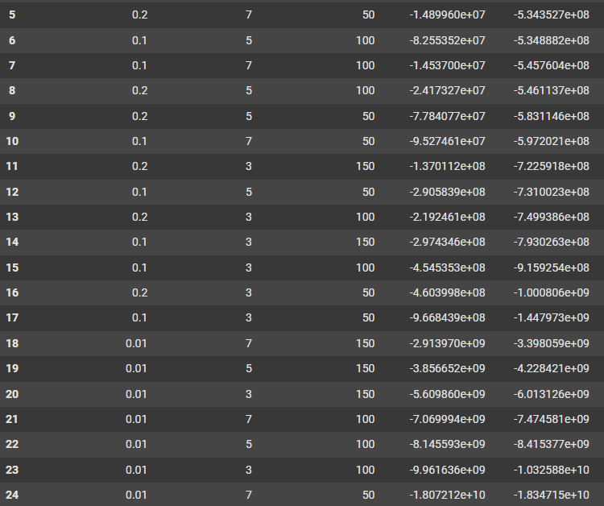



* 1. **Training vs. Validation Plot:** As the training size increases, the validation loss decreases and stabilizes at a point slightly above the training loss, meaning the model improves its generalization the larger the data.

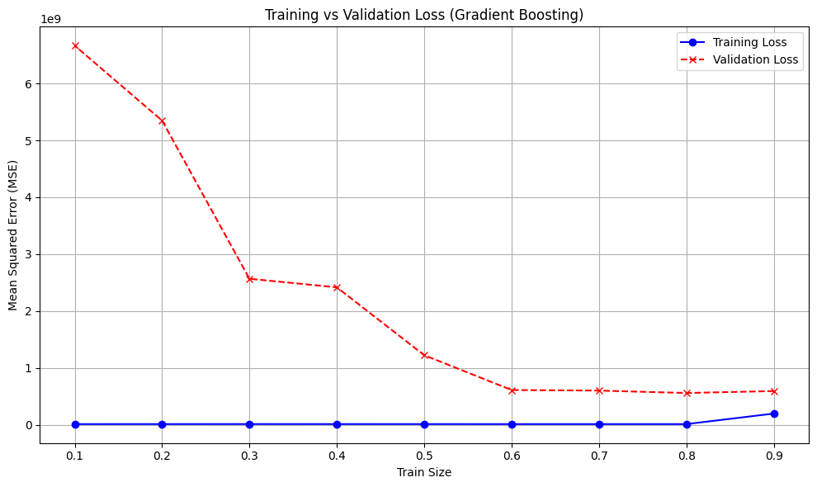

* 1. **Training vs. Testing Plot:** The training loss remains at a minimum value while the testing loss heavily increases with the training size. This indicates overfitting as the model performs exceptionally well on the training data but struggles to maintain such metrics when predicting.

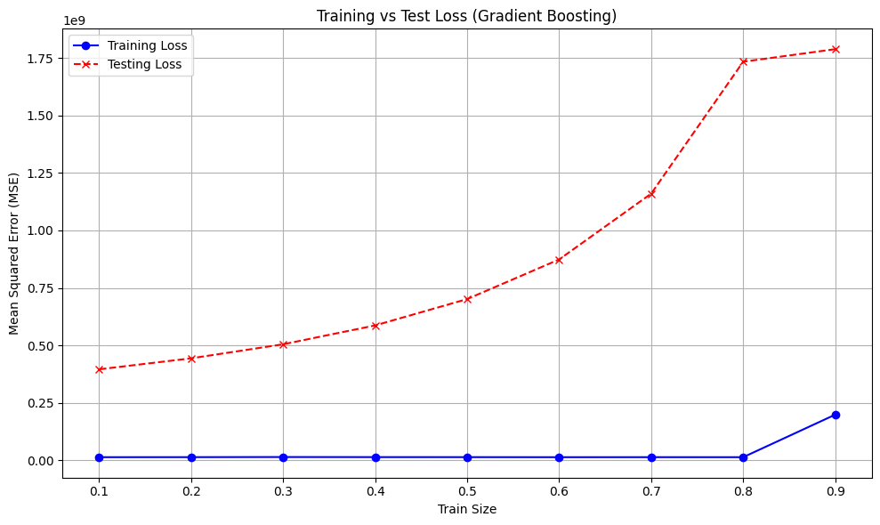

* 1. **Understanding – Potential Overfitting:** As the training data grows, the validation loss is decreased and slowly closing the gap between the relatively low, stable training loss. On the other hand, the Training vs. Testing Loss plot shows an obvious increase in testing loss as training size increases, which may indicate overfitting to the training set. This suggests that the model struggles to extrapolate to new data even when it is successful in identifying patterns in the training and validation sets.

1. **Random Forest**

|  |  |  |
| --- | --- | --- |
| **Top 5 Hyperparameter Combinations (In Order)** | | |
| **Combination:**  **[max depth, n estimators]** | **Training Performance** | **Validation Performance** |
| ***150, 7*** | -8.091729e+08 | -1.260029e+09 |
| 50, 7 | -8.123192e+08 | -1.281323e+09 |
| 100, 7 | -8.114573e+08 | -1.284279e+09 |
| 150, 5 | -1.859987e+09 | -2.259279e+09 |
| 100, 5 | -1.931983e+09 | -2.328997e+09 |

* **Remaining Combinations (Screenshots):**



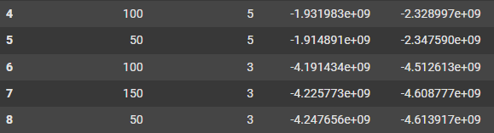

* 1. **Training vs. Validation Plot:** The validation loss decreases dramatically as the training sizes increase, stabilizing close to the training loss. This pattern shows that the model is able to increase its generalization abilities when more data becomes available.

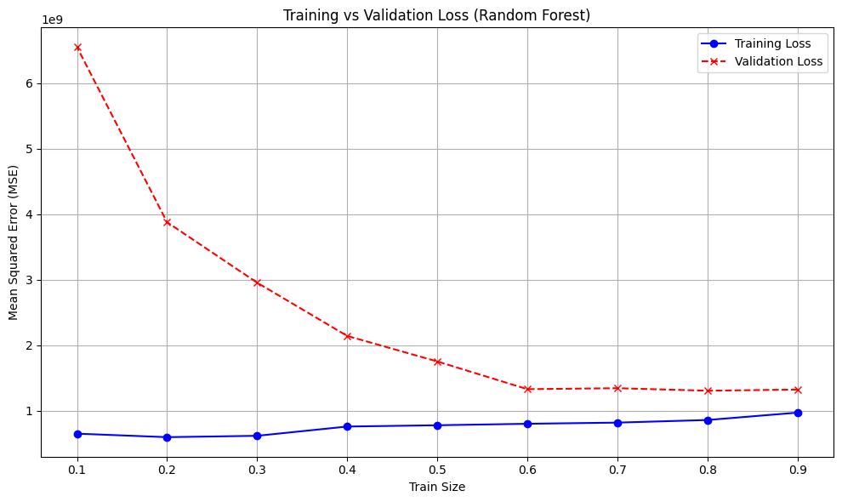

* 1. **Training vs. Testing Plot:** The training loss remains extremely low, but the testing loss increases significantly with training size, indicating potential overfitting.

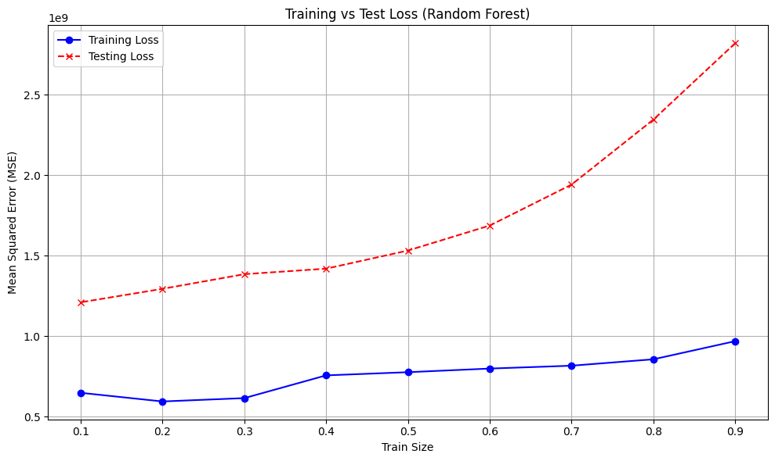

* 1. **Understanding – Potential Overfitting:** The Training vs. Validation Loss plot shows good generalization from the model as validation loss decreases and stabilizes near training loss as training sizes increase. But, similar to Gradient Boosting, the Training vs. Testing Loss plot shows a huge difference between training and testing losses, also suggesting potential overfitting as the model performs well on training and validation data, but it struggles to generalize to unseen test data.

1. **XGBoost**

|  |  |  |
| --- | --- | --- |
| **Top 5 Hyperparameter Combinations (In Order)** | | |
| **Combination:**  **[learning rate, max depth, n estimators]** | **Training Performance** | **Validation Performance** |
| ***0.2, 150, 5*** | -3.337809e+07 | -7.835120e+08 |
| 0.2, 100, 5 | -6.636346e+07 | -7.962021e+08 |
| 0.1, 150, 5 | -9.965110e+07 | -8.218460e+08 |
| 0.1, 100, 5 | -1.709842e+08 | -8.643635e+08 |
| 0.2, 150, 3 | -2.800156e+08 | -8.699521e+08 |

* **Remaining Combinations (Screenshots):**



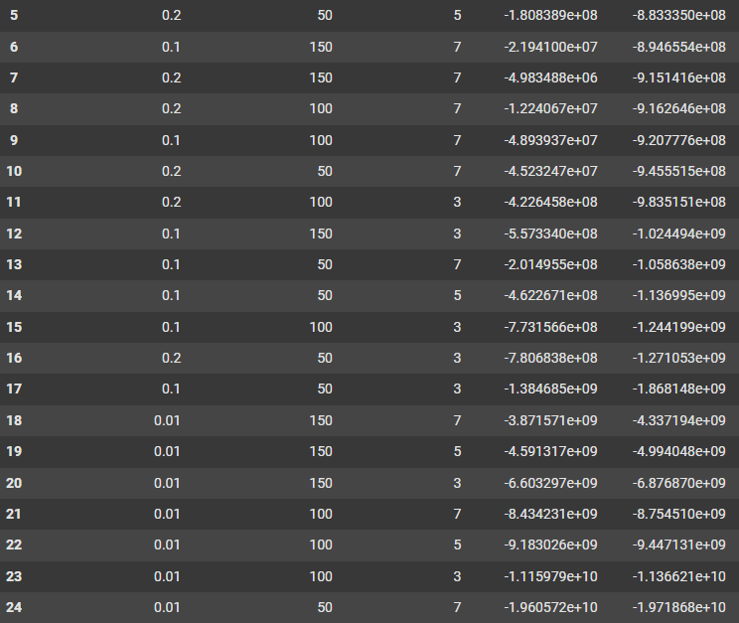



* 1. **Training vs. Validation Plot:** Similar to the above models, the XGBoost model suggests a well-balanced model that can generalize new data as the validation loss continues to lessen as the training data increases, closing the gap between the training loss.

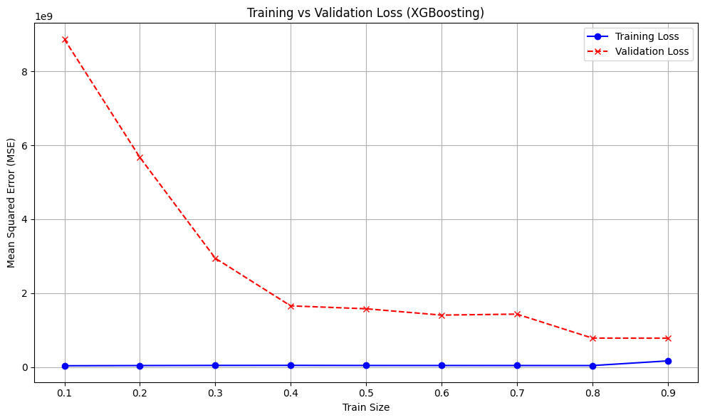

* 1. **Training vs. Testing Plot:** The training error continues to remain low consistently,

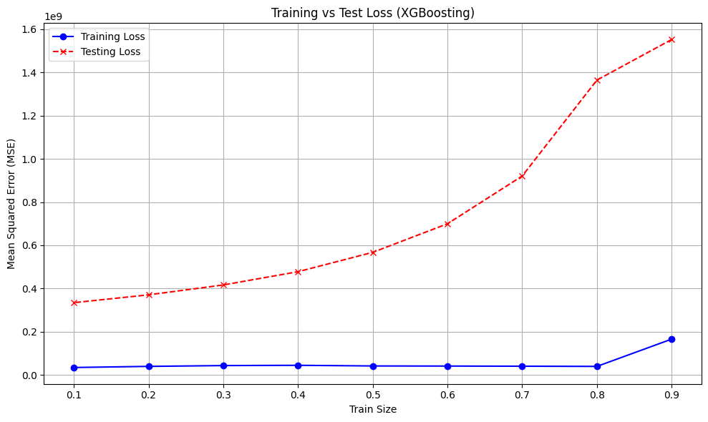

* 1. **Understanding – Potential Overfitting:** The Training vs. Validation Loss plot shows that XGBoost works well, showing good generalization and low validation loss that is close to training loss. However, overfitting is then suggested by the Training vs. Testing Loss plot, which shows an increasing difference between the two losses at bigger training sizes. The model works well on smaller datasets, but as the training size grows, it has trouble generalizing to test data that hasn't been seen yet.

And that brings my model health analyzation to an end. However, the question of which model is the best still remains. We’ll dive into this deeper in the next section.

# **5.4 Results: Analyzation**

Now that we’ve trained the models to find the best estimators, predicted using said best estimators, used model performance metrics on predictions, *then* compared the training vs. validation *and* testing loss, we can begin deeply analyzing all 4 models and discussing which model is best to use in our project and why, ranking their effectiveness from 1 (best) to 4 (worst):

1. **Polynomial Regression**

* **Performance:** Acting a decent baseline, achieving the **lowest metric errors** (MAE, MSE, RMSE) across all models in training, validation, and testing subsets, showing strong generalization of unseen data.
* **Target Explanation: S**hows decent explanatory power at an R2 value of 94%.
* **Computation Speed:** Quite fast at 38.48 seconds, proving to be an efficient model especially for smaller datasets.
* **Effectiveness Rank - 2:** Highly effective for smaller datasets due to its simplicity, minimal errors, and fast computation speed – however, its effectiveness decreases as the dataset size may increase, becoming to unable to continue understanding the complex relationships between the features and the target **Total Emissions**.

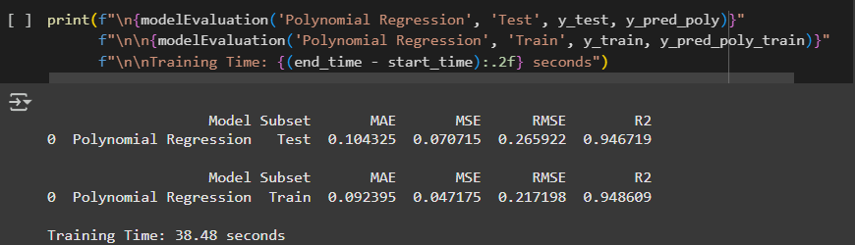

1. **Gradient Boosting**

* **Performance:** Is able to handle the more complex relationships between the features and target **Total Emissions** compared to Polynomial Regression, but suffers from higher metric errors (MAE, MSE, and RMSE).
* **Target Explanation:** Indicates quite good explanatory power at an R2 value of 96.6%
* **Computation Speed:** Has the *slowest* computation speed of all models at 302.22 seconds, reducing the model’s efficiency and preference use.
* **Effectiveness Rank - 3:** While Gradient Boosting can handle the more complex relationships and is more scalable than Polynomial Regression, it is still not as effective due to its high errors, slow computation, and suggested overfitting especially as the training set size grows.

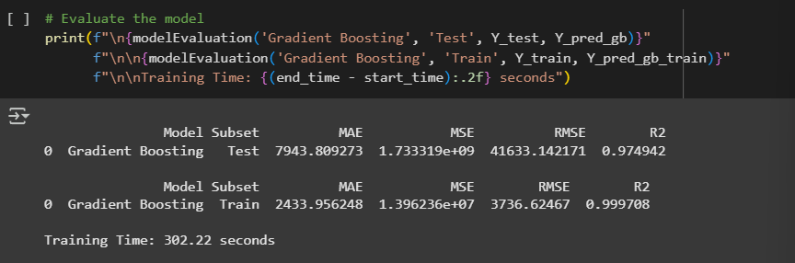

1. **Random Forest Regressor**

* **Performance:** Suffers from the **highest metric errors** (MAE, MSE, RMSE) across all models, showing the *largest* gaps between training and testing loss values.
* **Target Explanation:** Despite the large errors, the model shows decent explanatory power at an R2 value of 96.6%
* **Computation Speed:** Is quite moderate at 65.13 seconds.
* **Effectiveness Rank - 4:** Due to the *highest* provided errors across all models and overfitting issues, the Random Forest Regressor is the **least effective** model for this project.

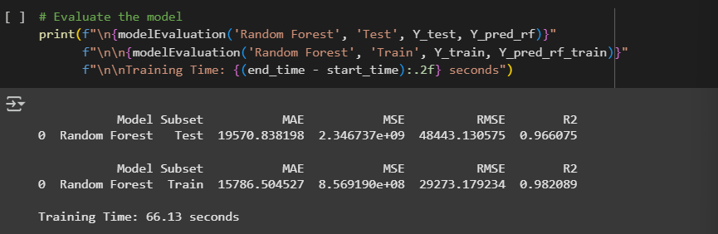

1. **XGBoost**

* **Performance:** Despite higher metric errors compared to Polynomial Regression, it still significantly outperforms Gradient Boosting and Random Forest all while showing *strong* generalization power for smaller training sizes.
* **Target Explanation:** The highest at an R2 value of 98%, showing the best explanatory ability.
* **Computation Speed:** Fastest at 23.83 seconds despite its advanced structure.
* **Effectiveness Rank - 1:** Combining *all* results together, despite the slight overfitting as the training size increases, the XGBoost model deems to be the **best and most effective model.**

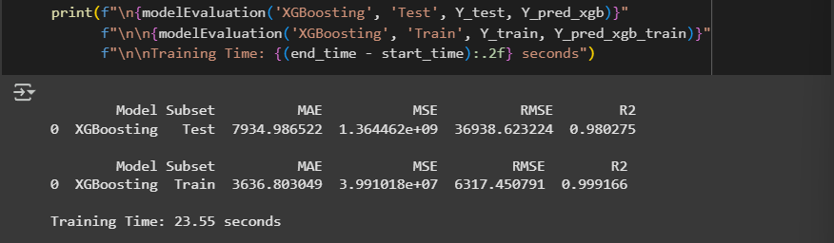

**Reviewed Ranking of Models (In Order):** XGBoost, Polynomial Regression, Gradient Boosting, Random Forest Regressor.

**Best Model – XGBoost, But Why?** Although Polynomial Regression showed *much* lower errors and its validation loss was closer to the training loss, XGBoost still remains the superior model.

* **Adaptability:** Despite Polynomial Regression’s better performance on *both* plots, it is important to note that the used data is extremely limited to only around 7000 rows for a global issue. Thus, its simplistic model structure is bound to fail to continuously capture complex relationships in larger data. XGBoost’s adaptability and flexibility will allow it to capture such complex data with further hyper tuning, allowing for greater scalability options.
* **Robustness:** Adding to the point above, XGBoost is able to maintain its high performance even as the dataset size or complexity increases. XGBoost also includes advanced hyperparameter options such as regularization to increase its robustness against overfitting, making the algorithm a safe option.
* **Higher R2:** Despite the model’s relatively high errors, its R2 value remains to be the highest at 98%, thus proving its effective ability of explaining 98% of the target variable’s variability and pattern.
* **Computation Speed:** Despite the XGBoost being an *advanced* Gradient Boosting model (Extreme Gradient Boosting), its computation time of 23.55 seconds is *still* relatively faster than all the other models: Gradient Boosting at 302.22 seconds, Random Forest at 66.13 seconds, and even Polynomial Regression at 38.48 seconds. This shows that despite its complex structure, the model still outperforms in terms of speed, showing its scalable, flexible *and* efficient nature.

Thus, overall, despite Polynomial Regression’s seemingly better results, it’s important to evaluate machine learning models on a larger and more future proof case to ensure the best choice. This is why understanding plots, model structures, and metrics are all important – combining all of these together aids us in understanding the results in front of us.

# **5.5 Models: Strengths vs. Weaknesses**

We’ve previously discussed the advantages and disadvantages of the 4 chosen models here. However, now that we’ve trained these models and predicted them, it’s essential to understand the **general**strengths and weaknesses of each algorithm to further assess the better model **for our specific project** of predicting **Total Emissions**. The following table summarizes the points needed:

|  |  |  |
| --- | --- | --- |
| **Strength vs. Weaknesses: All Models** | | |
| **Model** | **Strengths** | **Weaknesses** |
| **Polynomial Regression** | Lowest metric errors (MAE, MSE, RMSE) across *all* models in training, validation, *and* testing.  Simple hyperparameter options that are easy to understand and interpret, thus easy to hyper tune.  Decent explanatory power at 94%.  Second fastest computation speed at 38.48 seconds due to its simple structure, making it efficient for small datasets with potentially less complexity. | Simplistic model structure may struggle to capture more complex relationships with **Total Emissions**.  Lack of hyperparameter options can cause overfitting issues – high polynomial degrees can *easily* overfit especially in smaller data sets.  Is not able to handle **multicollinearity** inherently, which our dataset is **full of.** Manually removing *and* scaling features can lead to the removal of potential important patterns the model could’ve otherwise benefitted from.  Less scalable as evident in the Training vs. Testing plot – testing loss increases, even if at a smaller rate compared to other models. |
| **Gradient Boosting** | Can handle complex relationships due to its sequential building of weak learners that learn from the previous’ errors and corrects them one step at a time.  Good explanatory power at 97.4%. | Slowest computation speed across *all* models at 302.33 seconds, making it expensive and time inefficient *especially* when XGBoost exists – it is the faster, more advanced version of Gradient Boosting.  Dramatic increase of testing loss as training size grows despite good training vs. validation loss (small gap), indicating overfitting.  High reliance on hyperparameter tuning such as learning rate, max depth, *and* n estimators, needing proper understanding to properly tune to avoid overfitting. |
| **Random Forest** | Can handle complex relationships through its ensemble structure of building multiple decision trees and averaging their predictions.  Decent explanatory power at 96.6%  Moderate computation speed at 65.13 seconds – faster than Gradient Boosting as tree are built *parallel* rather than sequentially. | Highest metric errors across *all* models in training, validation, *and* testing.  Dramatic increase of testing loss as training size grows despite good training vs. validation loss (small gap), indicating overfitting.  Does *not* have a learning rate hyperparameter, taking the average of **all trained trees**, potentially leading to bias.  High reliance on n estimators and max depth – incorrect tuning can lead to overfitting. |
| **XGBoost** | Also known as Extreme Gradient Boosting, an advanced version of the Gradient Boosting algorithm with built in regularization to further build robustness against overfitting.  Best explanatory power at 98%.  Fastest computation speed at 23.83 seconds despite complex structure. | Its advanced structure is quite difficult to interpret, making it harder to properly tune hyperparameters for optimal performance.  Shows signs of gradual overfitting as training data size grows despite good training vs. validation loss (small gap), indicate slight overfitting. |
|  | | |
| **Takeaways: Final Thoughts** | | |
| **Polynomial Regression:** Great model for smaller training sizes, *however* data transformation (scaling and removal of multicollinearity) is needed for better performance, which potentially removes key features and patterns from the model could have learned from.  **End User Effectiveness:** Suitable for smaller scaled projects, however its preprocessing steps limits scalability and flexibility which reduces the model’s usability for users looking to gain deep insights into the relation between **Total Emissions** and *all* features. | | |
| **Gradient Boosting:** Despite its satisfactory performance, it is *not* the most preferred model due to its slowest computation speed, relatively high errors, and overfitting.  **End User Effectiveness:** Despites its accuracy, its slow computation speed is highly inefficient *especially* for users looking to use the model on larger scaled data and prioritize predictions that are fast and reliable. | | |
| **Random Forest:** The least effective model due to its slow computation speed *and* highest errors – lack of a learning rate hyperparameter could potentially be leading to bias from weaker tree predictions.  **End User Effectiveness:** Is not effective for users looking to derive data driven decision from the resulted predictions due to the high metric errors, causing the model to be unreliable. | | |
| **XGBoost:** Best overall model to its scalability, abundant hyperparameter options and flexibility, fastest computation speed, *and* internal regularization techniques against overfitting.  **End User Effectiveness:** The best suited model for almost *all* users, balancing adaptability, scalability, accuracy, speed, *and* explanatory capabilities – this model servers as a reliable source for data driven decisions. | | |

# **5.6 Future Improvements**

Although the trained models have produced some great results, there were still many limitations within the projects and thus improvements can be introduced to further produce more optimal outcomes *especially* when considering end users’ requirements such as environmental organizations and agencies, policymakers, governments, etc. Let’s explore some of these limitations and their potential fixes:

|  |  |  |  |
| --- | --- | --- | --- |
|  | | **Future Project Improvements** | |
| **Limitation** | **Description** | | **Mitigation** |
| **Multicollinearity** | The dataset, as previously shown through the correlation matrix (heatmap), is **filled** with multicollinearity. This poses a problem for linear regression algorithms like Polynomial Regression as multicollinear features function as duplicates. | | Avoid using linear regression models and stick to models that inherently deal with multicollinearity such as Gradient Boosting, Random Forest, & XGBoost.  However, the **dataset is *still* highly dimensional (28 features) and** may still benefit from PCA – this needs to be experimented to see whether reduction performs better than using all features or not. |
| **Dataset Size** | Considering the global scale of the issue of greenhouse gas emissions, this dataset size (~7000 records) is small. It does not directly reflect **real life data** as well as limits the performance of the more complex models such as XGBoost. | | Collecting more data or using data augmentation techniques (creation of artificial data from existing data) can help solve this issue of limited records to further explore the performance of complex models such as XGBoost. |
| **Dimensionality** | As previously mentioned, the dataset has *many* features (28 total), which could lead to overly complex and redundant relationships and pattern recognition – the models might start picking up on noise and memorizing records instead of *learning* and generalizing. | | Although models such as Gradient Boosting, Random Forest, and XGBoost inherently manage high dimensionality, manually working around the many features is *still* beneficial.  Asides from the previously mentioned PCA method, dimensionality reduction can be done through **feature engineering;** combining similar columns (such as Savanna and Forest Fires) can reduce feature complexity while maintaining potentially important relationships. |
| **Overfitting** | Every model has showed signs of overfitting, even if *minimal,* as the training vs. validation losses have small gaps but the training vs. testing losses does *not* reflect this generalization. | |  |
| **Hyperparameter Tuning** | All 4 models have shown exceptional performance in their training vs. validation loss across training sizes from 10% to 90%, indicating great generalisation to unseen data. But, this performance did *not* hold up well when plotting the training vs. testing losses – testing loss values significantly increased alongside the training data size. | | Usage of regularization methods in Polynomial Regression such (L1 and L2) can aid the model in decreasing its (minimal) overfitting as the dataset size increases.  As for Gradient Boosting, Random Forest, and (especially) XGBoost models, further understanding their other hyperparameters and tuning them through GridSearchCV can help us continue looking for their best estimator for better model performance and prediction all while reducing overfitting. |

By pinpointing limitations and addressing them, we can enhance our models' performance and make them more dependable, scalable, and practical for predicting **Total Emissions**.

# **Conclusions: End User Requirements**

As this project comes to an end, its study has shown how machine learning can be leveraged to predict global issues such as CO2 and greenhouse gas emissions. It’s important to note, additionally, that keeping in mind **end users** (environmental organizations and agencies, policymakers, governments, etc.) when creating such a project is crucial to further assess the models’ effectiveness at meeting their requirements. Through my machine learning model creation, XGBoost has emerged as the **best model** due to its balance between speed, adaptability, scalability, *and* explanatory capabilities. Although there exists issues in the dataset and models – such as extreme multicollinearity, small number of records, overfitting, and a lack of proper hyperparameter tuning – these issues have been pinpointed with mitigation strategies to continue the further enhancement and development of the project for more accurate results and robust models.

# **References**

1. Bello, A.L. (2023). Agri-food CO2 emission dataset - Forecasting ML. [online] Kaggle.com. Available at: https://www.kaggle.com/datasets/alessandrolobello/agri-food-co2-emission-dataset-forecasting-ml/code [Accessed 23 Jan. 2025].
2. GeeksforGeeks (2024). Random forest algorithm in machine learning. [online] GeeksforGeeks. Available at: <https://www.geeksforgeeks.org/random-forest-algorithm-in-machine-learning/>.
3. GeeksforGeeks (2020). Gradient Boosting in ML. [online] GeeksforGeeks. Available at: <https://www.geeksforgeeks.org/ml-gradient-boosting/?ref=header_outind>.
4. GeeksforGeeks (2024). Linear vs. Polynomial Regression: Understanding the Differences. [online] GeeksforGeeks. Available at: https://www.geeksforgeeks.org/linear-vs-polynomial-regression-understanding-the-differences/?ref=header_outind [Accessed 23 Jan. 2025].
5. GeeksforGeeks (2020). XGBoost for Regression. [online] GeeksforGeeks. Available at: https://www.geeksforgeeks.org/xgboost-for-regression/?ref=header_outind [Accessed 23 Jan. 2025].
6. Boosting in ML: Enhance Your Model’s Accuracy. (2025). Boosting Techniques in Machine Learning: Enhancing Accuracy and Reducing Errors. [online] Available at: https://www.grammarly.com/blog/ai/what-is-boosting/ [Accessed 23 Jan. 2025].
7. GeeksForGeeks (2024). What are the Advantages and Disadvantages of Random Forest? [online] GeeksforGeeks. Available at: <https://www.geeksforgeeks.org/what-are-the-advantages-and-disadvantages-of-random-forest/>.
8. www.kaggle.com. (n.d.). Agri-food CO2 emission dataset - Forecasting ML. [online] Available at: <https://www.kaggle.com/datasets/alessandrolobello/agri-food-co2-emission-dataset-forecasting-ml>.
9. Anon, (n.d.). Factsheet – What is the IPCC? — IPCC. [online] Available at: <https://www.ipcc.ch/factsheet-what-is-the-ipcc/>.
10. Food and Agriculture Organization of the United Nations (2021). [online] PRD-FAO Home. Available at: <https://www.fao.org/home/en>.
11. Tung, N.X. (2023). Is linear regression especially well suited for scaling? - EITCA Academy. [online] EITCA Academy. Available at: <https://eitca.org/artificial-intelligence/eitc-ai-mlp-machine-learning-with-python/regression/understanding-regression/is-linear-regression-especially-well-suited-for-scaling/>.
12. www.javatpoint.com. (n.d.). Hyperparameters in Machine Learning - Javatpoint. [online] Available at: <https://www.javatpoint.com/hyperparameters-in-machine-learning>.
13. GeeksforGeeks (2023). R Squared | Coefficient of Determination. [online] GeeksforGeeks. Available at: <https://www.geeksforgeeks.org/r-squared/#what-is-rsquared>.